In-Ved power T&D webinar. 2025. https://www.youtube.com/watch?v=QOgbitdPLmU

* Transmission encompasses transmitting electricity from power generation to power consumption centers, typically the substations.
* Distribution involves moving the power from substations, which receive the power from power generators via transmission, to end consumers.
* In India, government capex determines the kind of business opportunities in the transmission sector, including which segments, their growth, and end product sales, as well as which part of the value chain and where; crowding-in can also create incentives for private capex. A similar logic should apply in other geographies basis their regulatory structure, with both private and public capex.
* Transmission is usually power transmission at 44/111 kV and above, going up to 440/765/1100 kV for long distance, inter-state transmission lines.
* Power demand increases at almost a similar pace as NGDP.
* Why is transmission capex happening:
  + Long distance power transport
  + Load management
  + Grid stability and reliability: Accommodating renewable ramp up and ramp down, as well as integration of other power sources as complementary requires additional capex to ensure grid stability
  + Integrate renewables: Renewables are not available round-the-clock (RTC)
* Where is capex happening (i.e., three parts of the basic transmission infrastructure)
  + Cables and conductors: HVDC lines, HVAC lines, aluminum/copper wires and cables, overhead lightning protection line, etc.
  + Tower structures: Comprise poles, PI structures, and tower structures. Can go as high as 50 m.
  + Substation (50-60% of expenditure): Stepping up or step down of voltage to transmit power between different stages using transformers and other equipment to ensure that the properties of power on the input side of the substation are transformed so that they match the properties of power on the output side; e.g., connecting renewable power generation requires changing the alternating and fluctuating current to HVDC properties and other voltage and current requirements of the grid so that it is transmitted reliably. Major equipment: transformers (power, potential, and current transformers), protection equipment (surge arrestor, insulator, circuit breaker/bushings; all serve to protect against unanticipated or unplanned changes in the qualities of power, such as receiving higher voltage than the equipment’s input rating), etc.
* Good questions/thoughts/things to search
  + How much additional transmission is needed for every additional GW of generation capacity of different types (renewable, battery, coal, gas, nuclear, etc.)
  + Essentially transmission helps match demand and supply
* Power T&D value chain

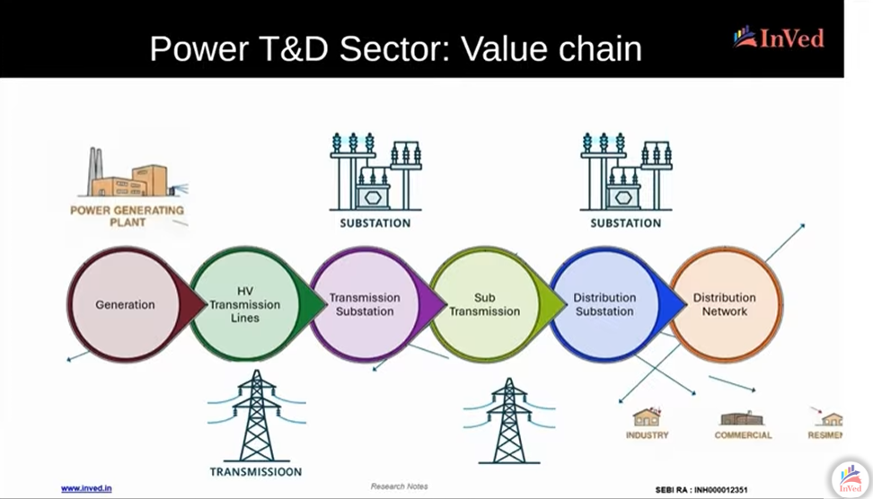

* + Generation > HV transmission (765/1100 kV) > Transmission substation > Sub-transmission > Distribution substation (1/11 kV) > Distribution network

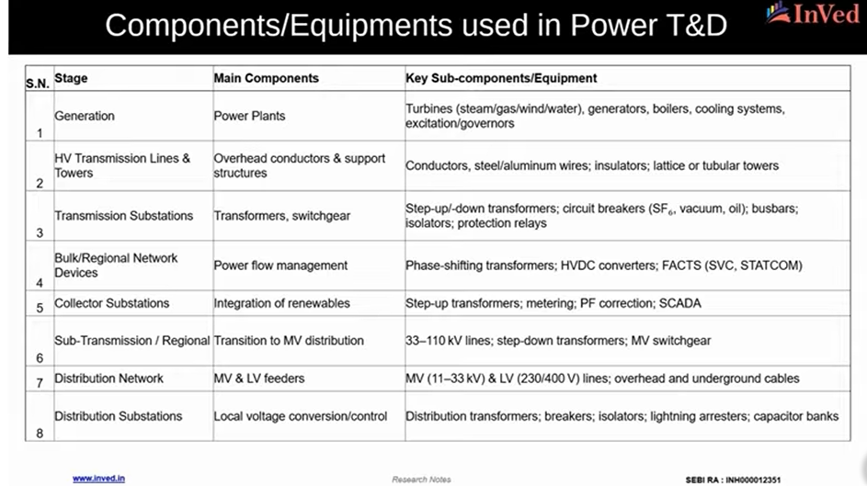

* Power infrastructure – Towers

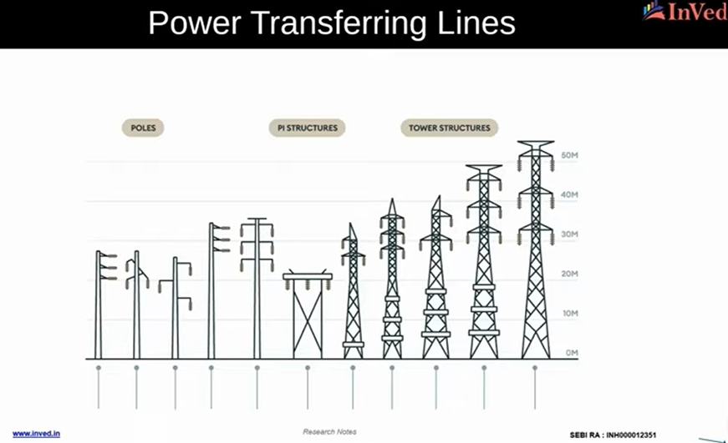

* Power infrastructure – Substation

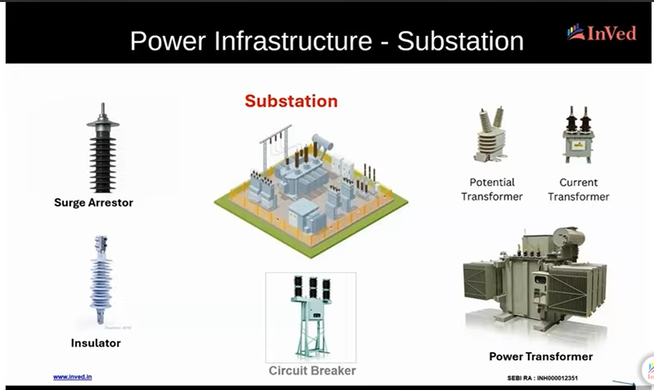

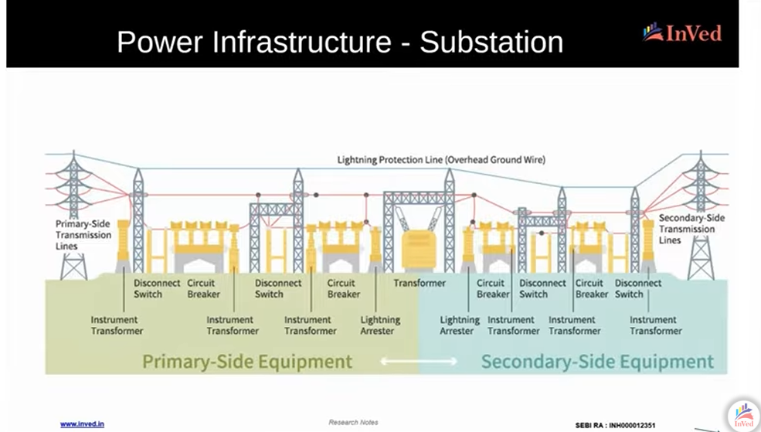

* + Power infrastructure – Cables

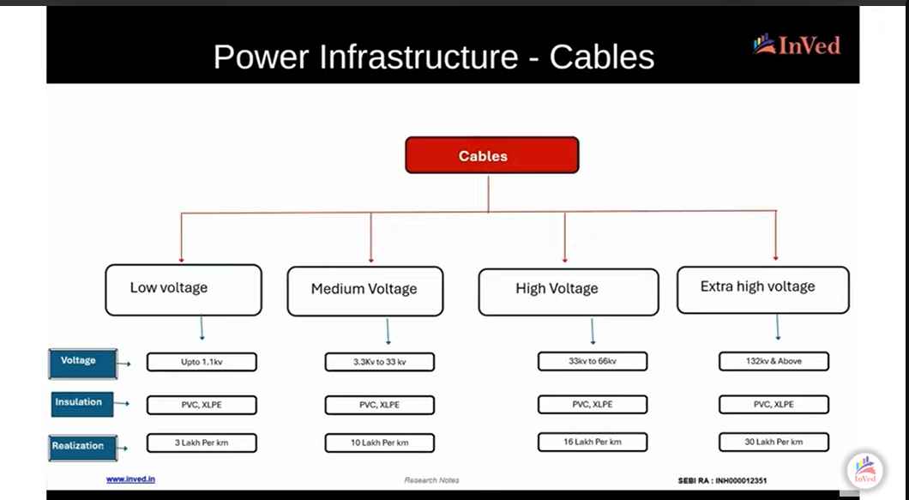

* Conductors vs cables

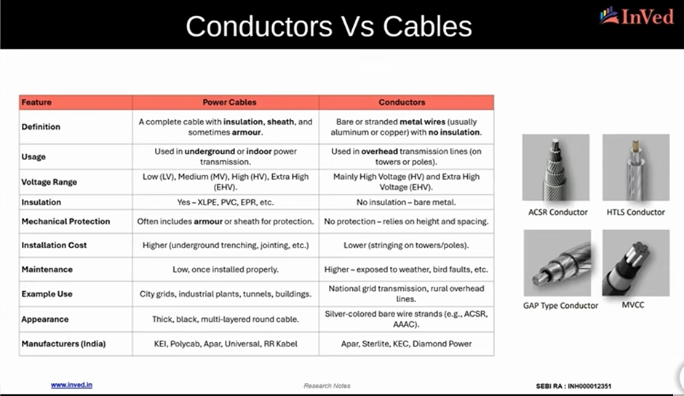

* HVDC: An emerging opportunity
  + Typically, AC power transmission mode is used as it is cheaper over shorter distances. However, HVDC has emerged as a viable and cheaper option beyond a certain transmission distance (around 250 km) for moving large amounts of power.
  + It involves a converter substation which first changes power from AC to DC, then transmitting DC power over large distances, and then another converter substation changing DC to AC nearer to the end point.
  + It is particularly relevant given the growth in distant power generation sites, such as offshore wind, remote large scale solar projects, and large hydro, which are far away from demand enters.
  + In India, GoI is planning around 7-8 HVDC projects from FY27. Each project has a capex of Rs. 25,000 crore. Total opportunity size is around Rs. 2-2.5 lakh crore.
  + Very few players in not only India but also globally in this sector. These players will have disproportionate order books. Companies: Universal Cables (some exposure), Quality Power (some exposure), GE Vernova, Siemens, Hitachi.

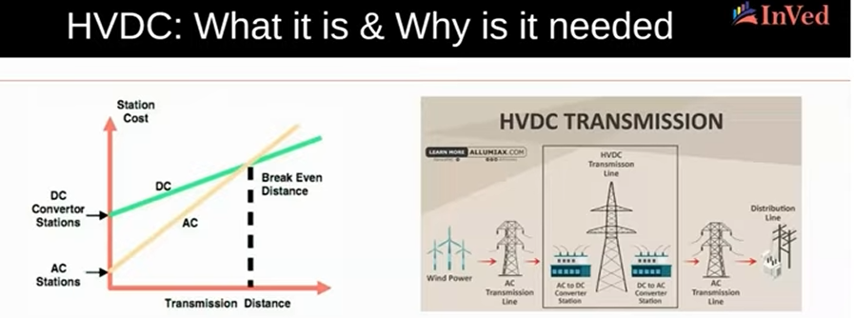

* A high-value portion of HVDC: FACTs
  + FACT: Flexible AC Transmission Systems
  + Power electronic devices (i.e., use semi-conductors) used in AC grids for more controllable, stable, and efficient transmission, encompassing static controllers.
  + Placed at strategic power network points for nearly instantaneous power switching; and hence, are faster than mechanical devices.
  + Basically, help balance and smoothen things quickly for stability in terms of voltage and flow during dramatic fluctuations in these power properties.
  + Useful with greater power variability in grid given renewables integration.
  + GoI requires FACTS deployment in at least 33% of renewable parks to manage reactive power and maintain voltage stability.
  + Very few players are in this: GE Vernova, Siemens, Hitachi, Quality Power (very small). Demand and supply mismatch is there.

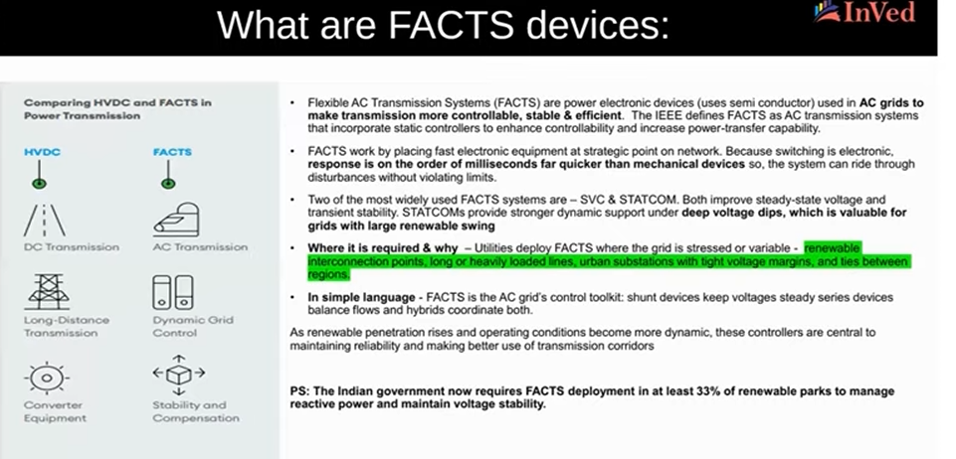

* Govt. data
  + NEP:
    - Key investment insights are in 20-25 pages.
    - 9 lakh crore of transmission capex until 2032.

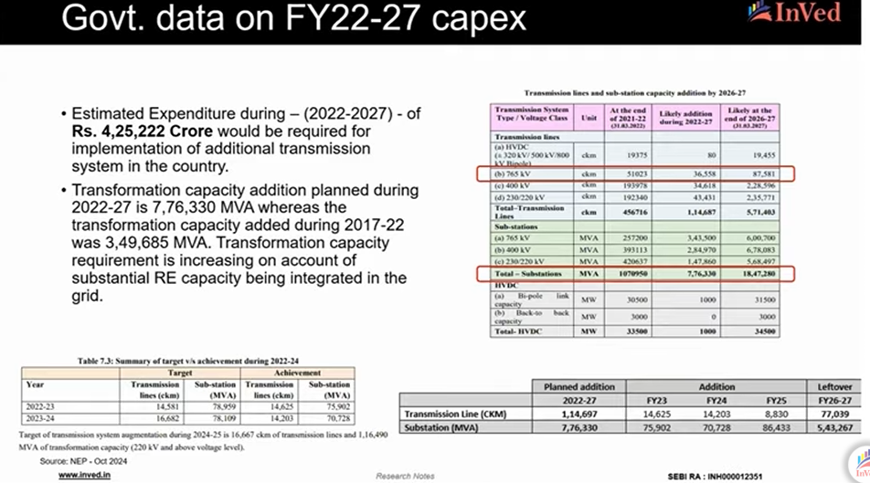

* + Capex CAGR highest in 765 KV and substations. Additions have lagged target, with 60-70% expenditure remaining to be completed in FY26-27.
  + Challenges remain like right of way issues.

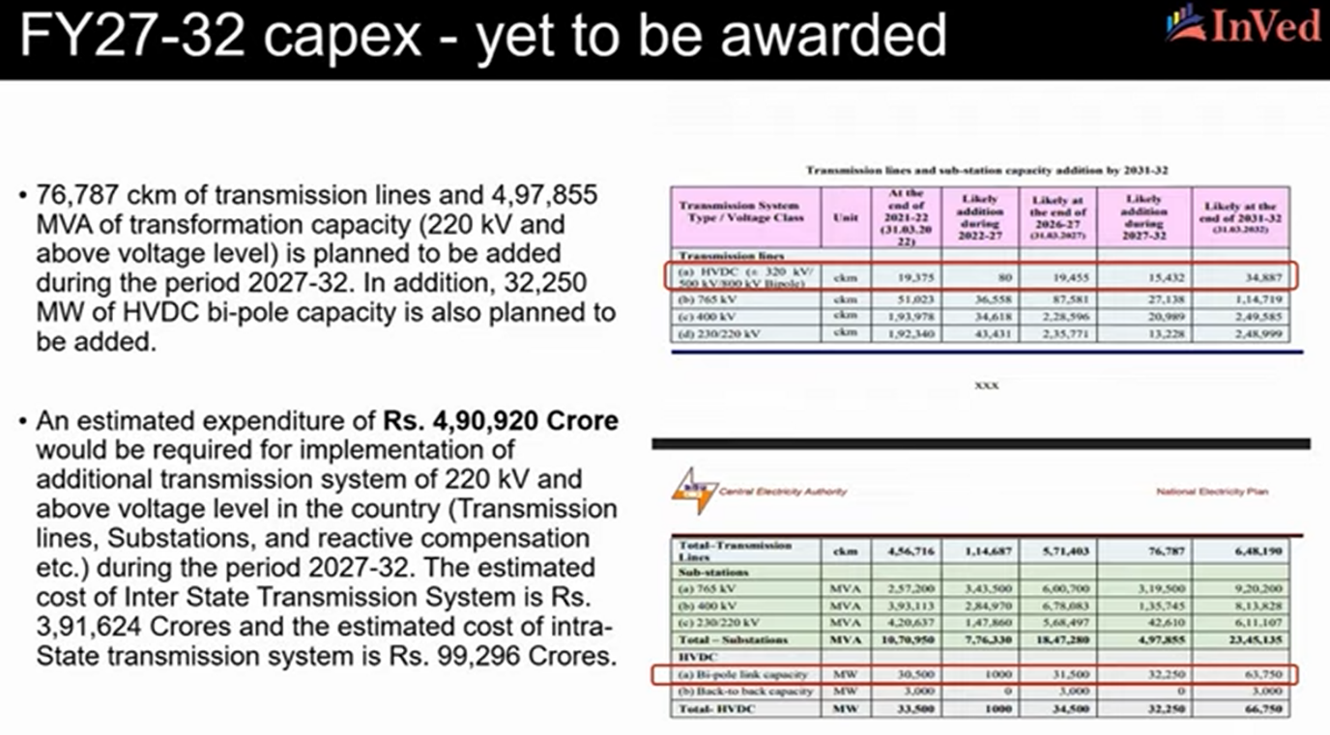

* + Interestingly, Rs. 4.9 lakh crore capex is planned for FY27-32, with HVDC capacity doubling. Of this, ISTS capex at Rs. 3.92 lakh crore and intra-state transmission system capex at Rs. 0.99 lakh crore.

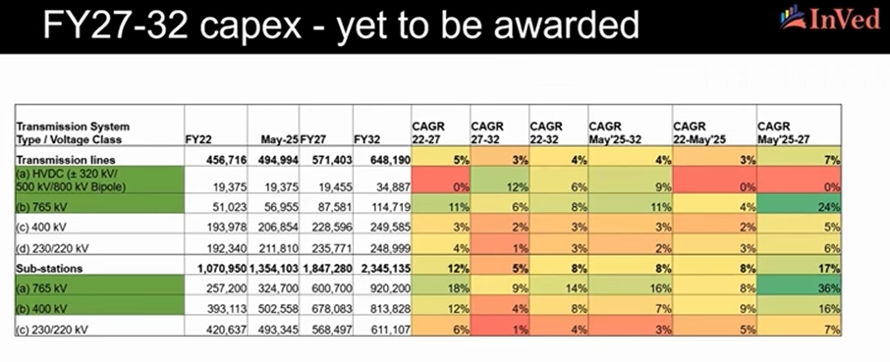

* + Highest growth areas:
    - HVDC
    - Transmission lines: 765 kV
    - Substations: 765 and 400 kV
    - Companies in these areas are enjoying higher valuations and growth. Crucially, supply is constrained in higher kV for transformers, conductors, towers, and other equipment.
  + Crucially bulk of FY22-32 is yet to be allocated, as only Rs. 3 lakh crore has been allocated, Rs. 6 lakh crore is yet to be allocated. Even in the Rs. 3 lakh crore, a majority is sitting on the order books of Power Grid (Rs. 1.5 lakh crore) and Adani (Rs. 0.5 lakh crore). So only Rs. 1 lakh crore has been implemented.

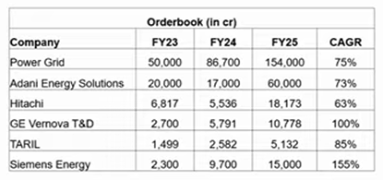

* + Order books have grown by more than 60-70% over the last three years.

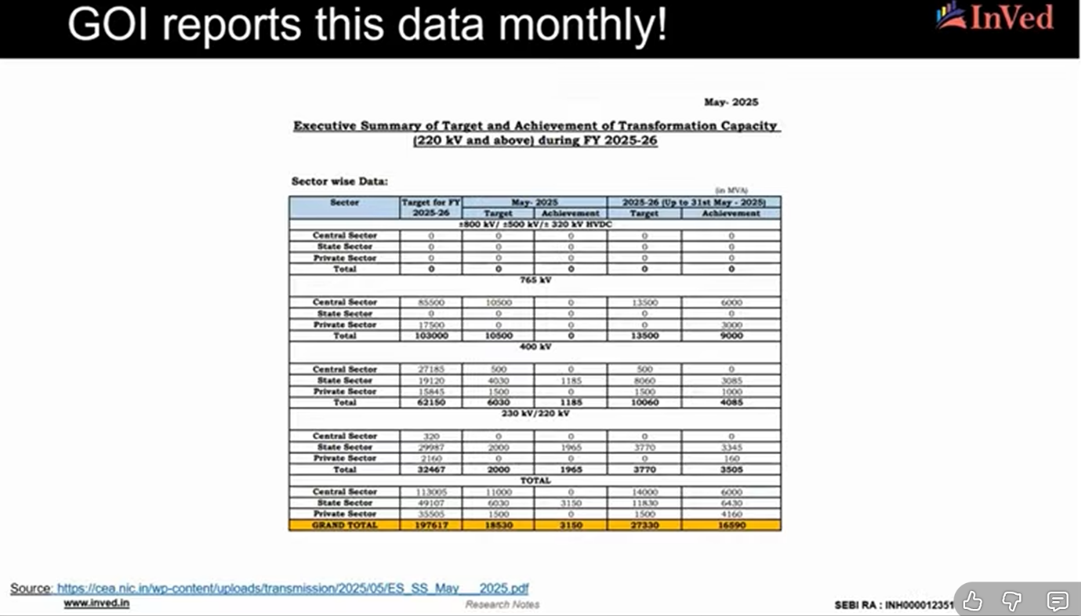

* + Notably, the majority of achievement happens in H2.
  + A majority of capex is planned for H2FY26.
  + HVDC Capex

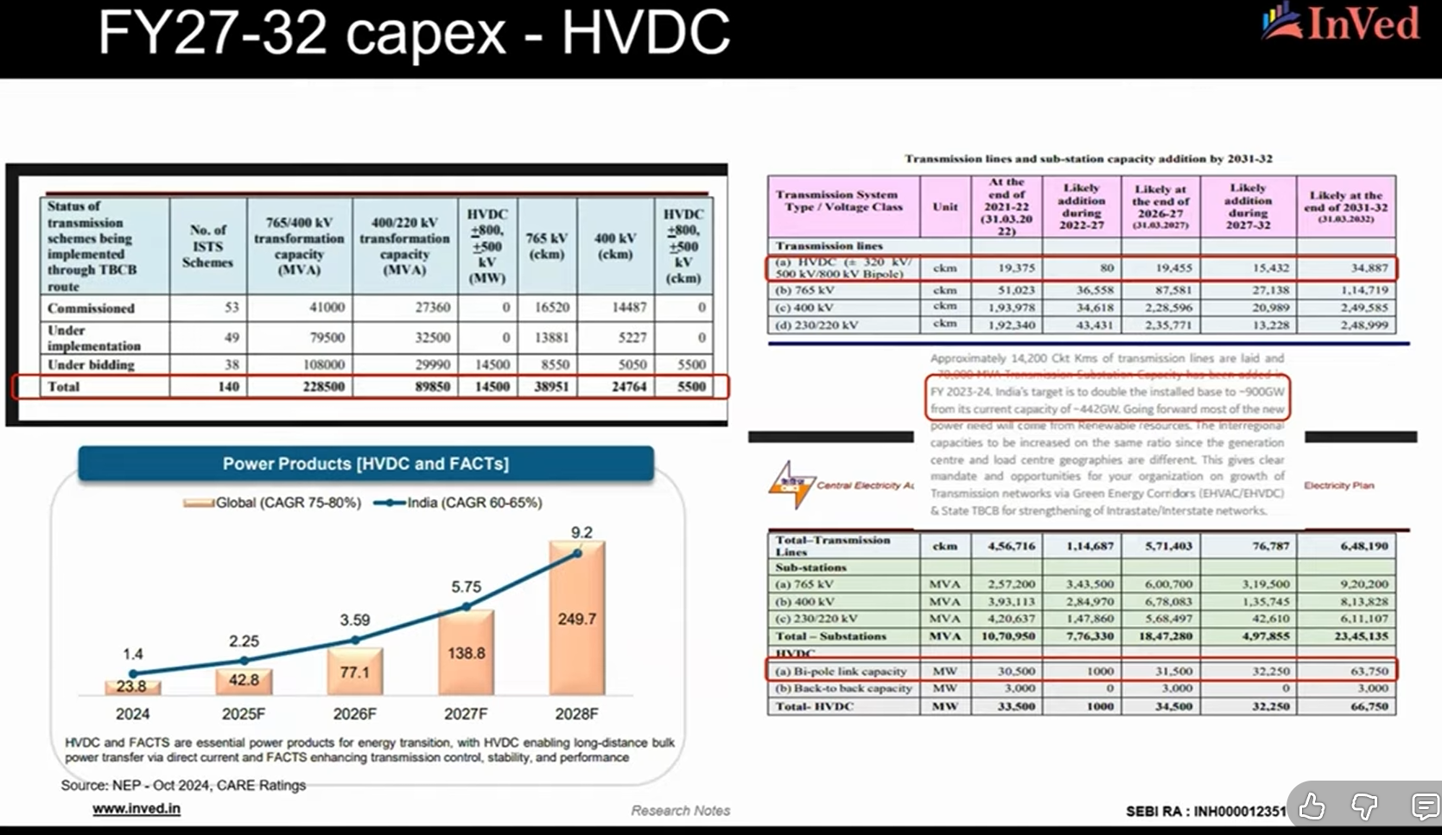

* + - Massive growth in HVDC segment globally and in India, growing at more than 60-70% CAGR
    - HVDC to double until 2032, with most expenditure planned after FY27.
* However, these GoI data primarily include transmission, and not distribution (covered under Revamped Distribution Sector Scheme (RDSS) with planned outlay of Rs. 3 lakh crore) and private capex (e.g., individual data centers). This means that overall planned capex would be higher than the Rs. 9 lakh crore number. Other ad-hoc and other announcements of nine 1100 kV lines and Indo-Middle East power lines may entail additional outlays.
* TAM
  + Summary of PowerGrid capex

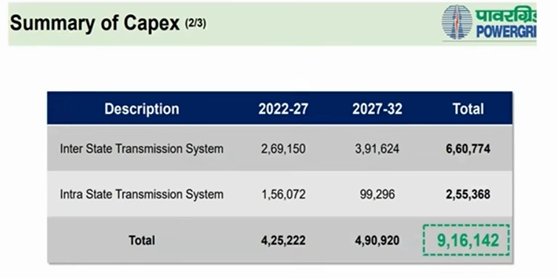

* + TAM analysis

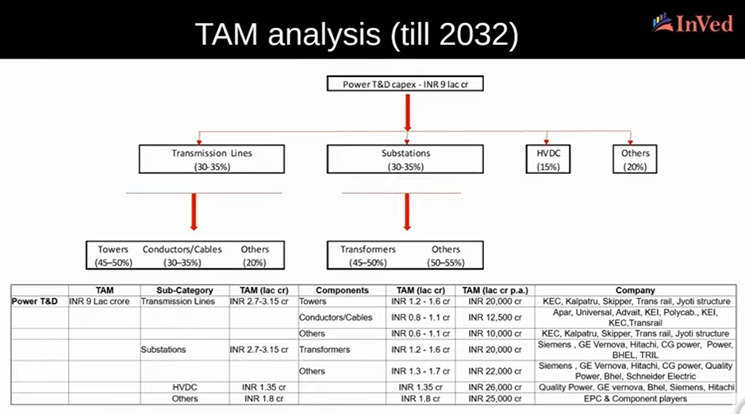

* + Industry structure (as per tariff based competitive bidding (TPCB))

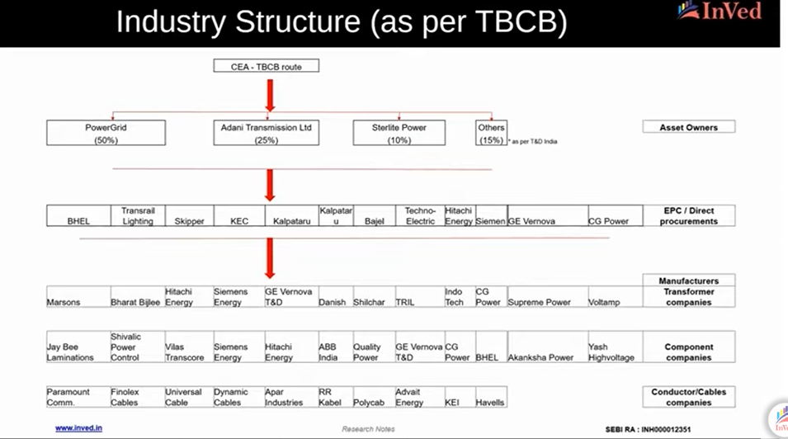

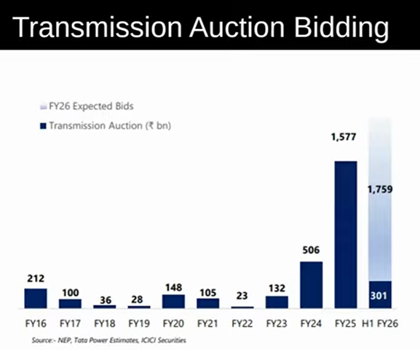

* Distribution

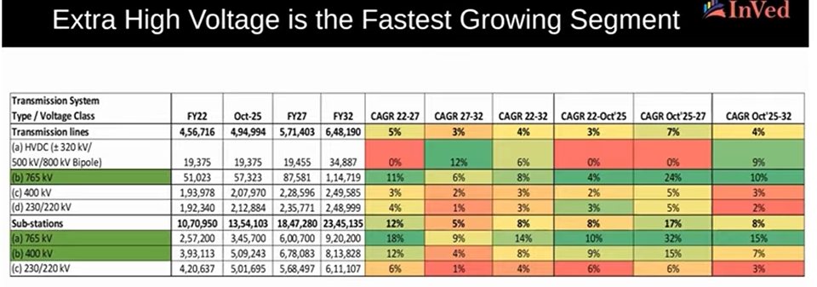

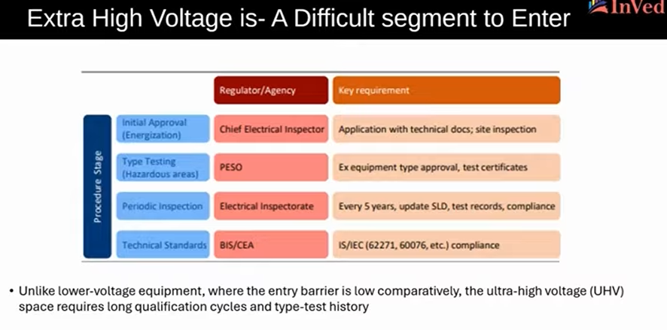

* Overall, three key high-growth segments emerge: higher kV, HVDC, and EHV.

Part 2: https://www.youtube.com/watch?v=4Pte-qaWOFE

* Transformers

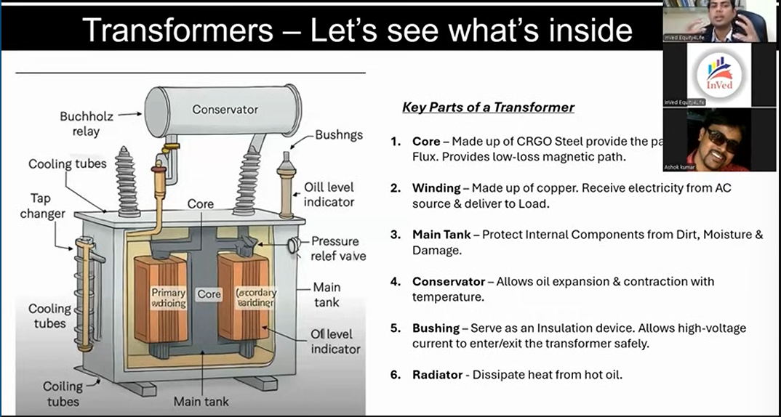

* + Key parts:
    - Core: CRGO specialized steel, typically imported from China.
    - Winding: Copper based.
    - Main tank: Protects internal components from dirt, moisture, and damage.
    - Conservator: Allows oil expansion and contraction with temperature.
    - Bushing: Insulation device, safely allowing high-voltage current. Used mainly in high voltage transformers; limited usage in low-voltage transformers. Only few companies make it.
    - Radiator: Dissipates heat.
  + Types:

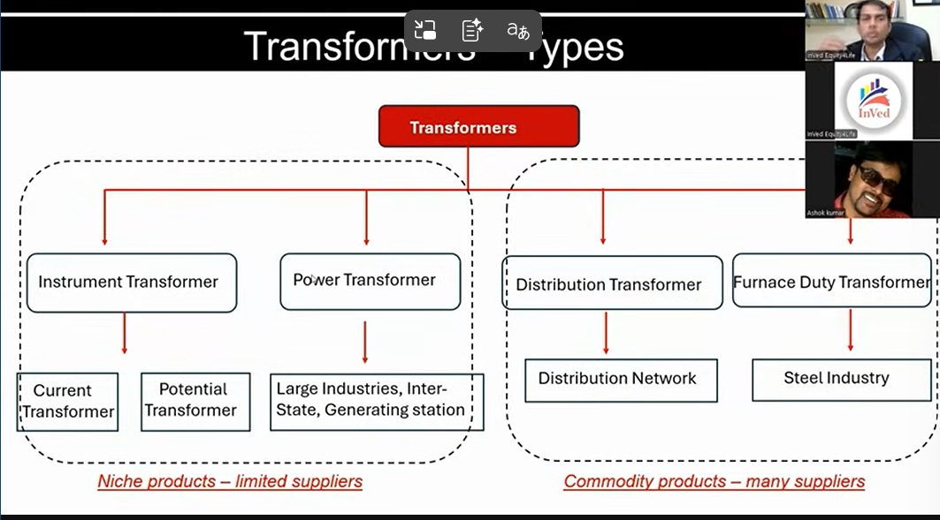

* + - Left side transformers are higher kV products, with few making this. Bulk of growth is happening here.
    - Right side transformers are more commodity and lower kV products, with many making it.
  + Key aspects to analyze transformer company:
    - Transformer type – kV
      * Higher kV
      * Lower kV
      * Specialized transformers, e.g., IDTE transformers (but this is also commoditized).
    - Export versus domestic
      * Exports fetch 2-2.5x ebitda realization.
      * However, approval cycle is 4-5 years.
      * US market is most attractive, albeit with 5-8 year waiting periods.
      * Shilchar does higher margins despite lower kV products because it is more export focused.
    - Capacity expansion
      * Some capacities are coming online later in FY28/FY29. Others have it coming online in H2FY26/H1FY27; the latter will be rewarded faster.
    - Margins and working capital
      * Leaner operations are better.
      * 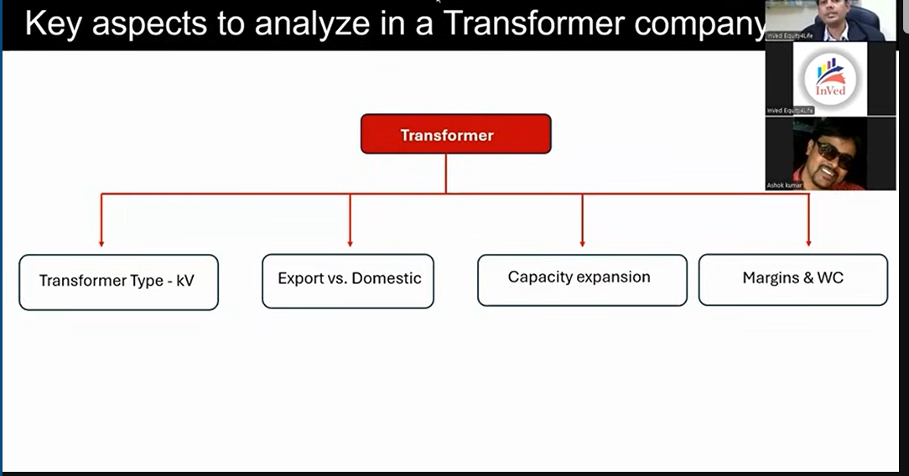Higher margins are better.
  + Key companies
    - TRIL
      * One of the few higher kV players.
      * Capacity: Current 40k MVA capacity (27k MVA extra high voltage). 15k MVA medium voltage capacity and 22k MVA addition in extra high voltage MVA capacity.
      * Exports: 3% revenue.
      * Working capital: Margins from 7% to 16% in FY25. Working capital days improved from 90 to 34 days.
      * Fell due to World Bank ban news and other stuff; non-event as this revenue will come in Q3FY25. Plus company is doing background integration, adding 2-3% to margins with potential for 20% EBITDA margins.
    - Atlanta electricals
      * Largest power and distribution transformers of up to 765 kV. Would be able to even manufacture 1100 kV transformers with recent acquisition. Makes IDT transformer.
      * Special situation: Acquired defunct Chinese company with high voltage manufacturing capabilities.
      * Capacity: 63k MVA capacity and adding 5k MVA.
      * Exports: negligible. 20 crore order won.
      * Working capital and margins: from 8% in FY22 to 16% in FY25. Working capital remains at 51 days.
    - Shilchar
      * Electronics, telecom, power and distribution transformers, and IDT transformers.
      * Current capacity at 7.5k MVA and adding 6.5k MVA, with increasing capacity manufacturing to up to 100 MVA and 220 kV.
      * Export: 43% in FY25, rising from 25% in FY22.
      * Working capital and margin: From 11% in FY22 to 30% in FY30. Working capital high at 100 days.
    - Voltamp Transformers
      * Power and distribution transformer, compact substation, and ring main unit. Non-PSU business, focusing mostly on private industrial clients. Lowest debtor days. Manufacturing up to 220 kV.
      * Capacity at 14k MVA and adding 6k MVA.
      * Exports: 2%
      * Working capital & margin: From 8% in FY22 to 16% to FY25. While working capital is at 74, but payables are negligible together with best margins.
    - Bharat Bijlee
      * Up to 200 MVA and 220 kV under power systems business.
      * Capacity at 18k MVA and adding 17k MVA operational by FY27.
      * Export: 1%
      * Working capital and margin: Power system margins rose from 6% in FY22 to 15% in FY25. Working capital improved from 100 days in FY24 to 73 days in FY25 due improving mix of non-tender business.

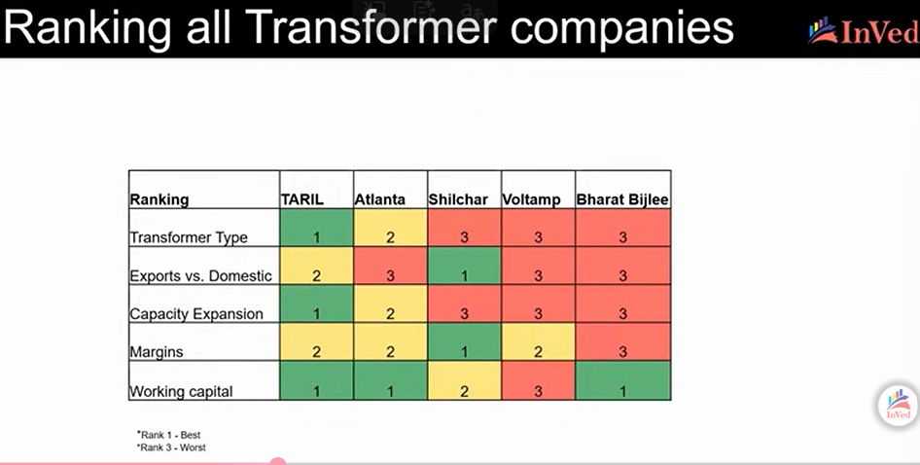

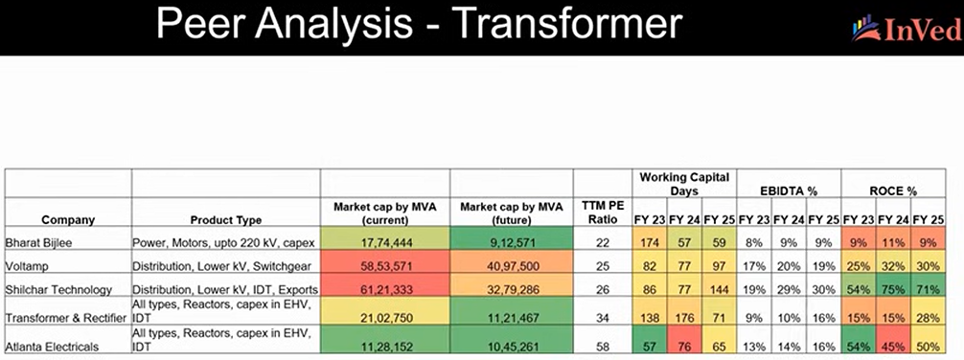

* Transformer component manufacturers

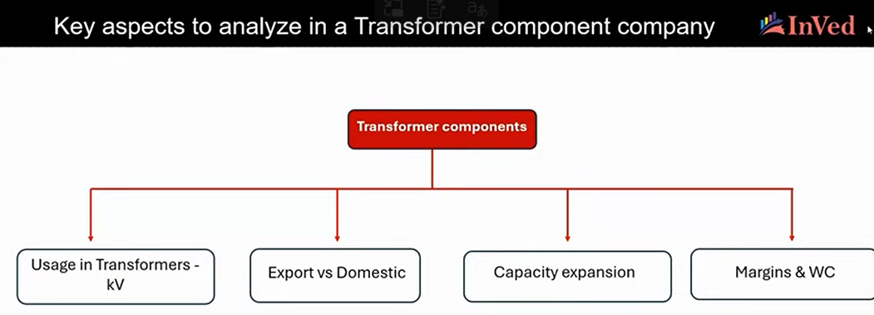

* + Vilas transcore
    - CRGO laminated and nano crystallin cores, and raditors
    - Capacity going from 12k MTPA to 36k MTPA in FY26. Entering all transformer components and into copper winding used in power transformers.
    - Working capital and margins: Increased to 13% in FY25 from 10% due to CRGO steel supply deficit and price increase. Working capital remains at 100 days.
  + Jaybee Laminations

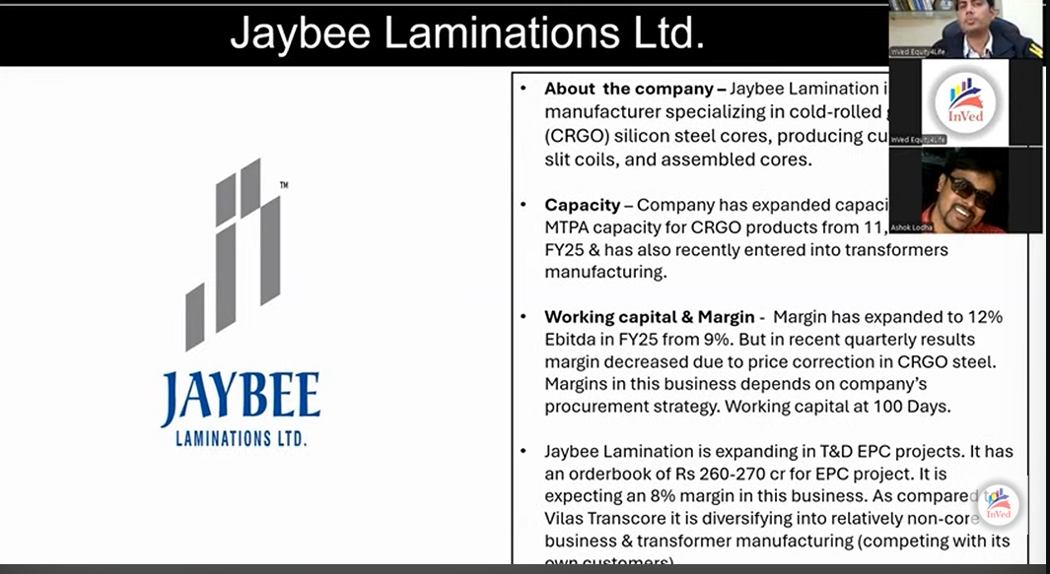

* + Mangal Electricals

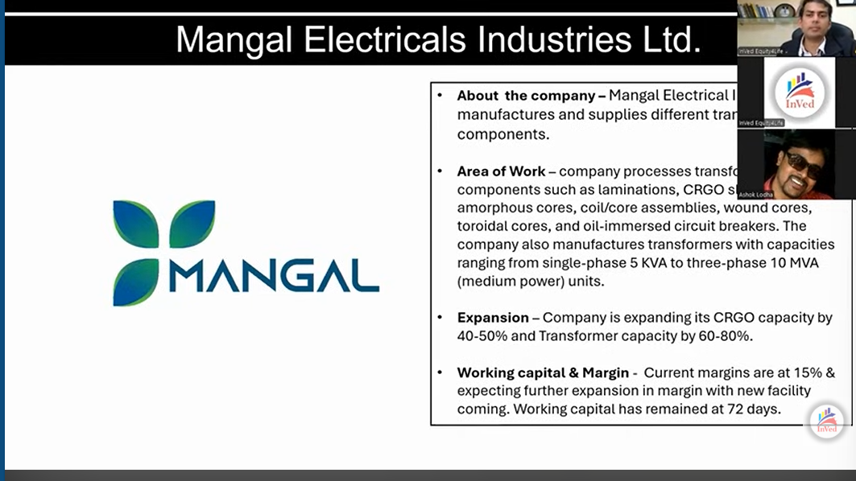

* + Yash High Voltage
    - Transformer bushing manufacturer. Hardly 10-12 companies making it due to complex product.
    - Two types: Manufacturing oil impregnated (OIP) and resin impregnated paper (RIP). RIP is used more in higher voltage applications and mostly for exports.
    - Higher kV segment capex of 500 kv from current capacity of 245 kV, increasing capacity from 9k to 15k bushings. Also backward integrating.
    - Working capital and margins: Niche product commanding 20% margins, with further expansion expected with new capacity for even more niche products. Working capital remains at 45 days.
    - Most moated business.
  + Comparison of component manufacturers

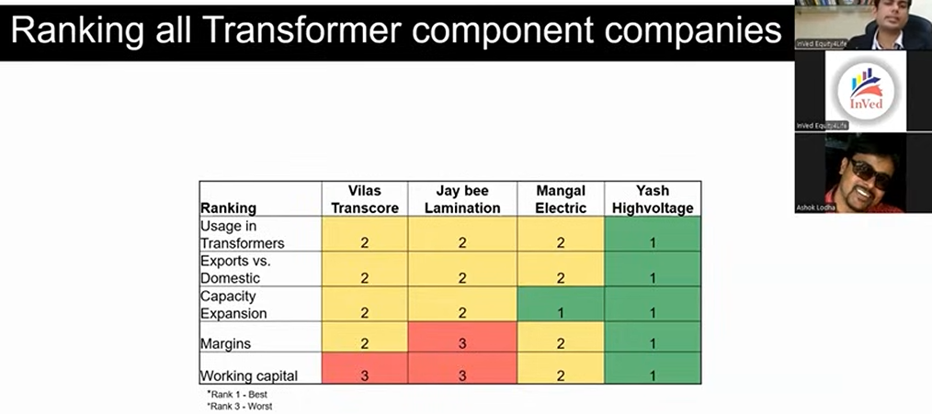

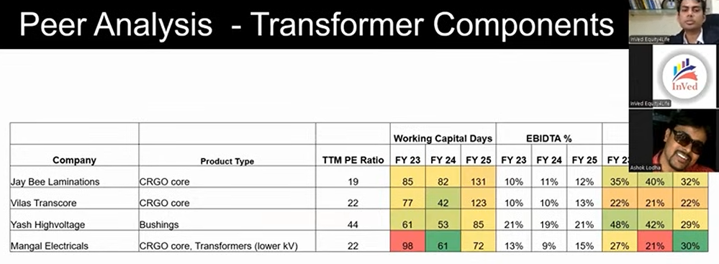

* + Transformer sector outlook

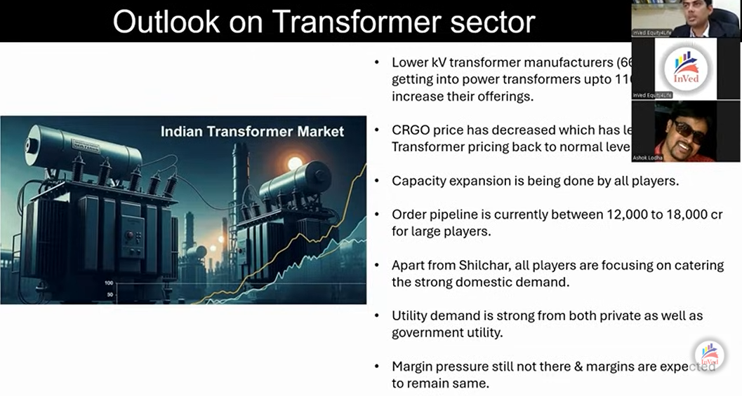

* + Top three companies fundamentally: TRIL, Atlanta, and Yash High Voltage
* Wires and Cables

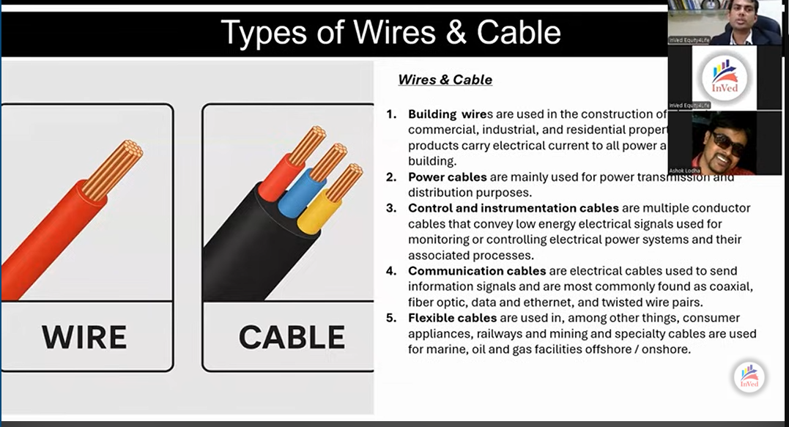

* + Types

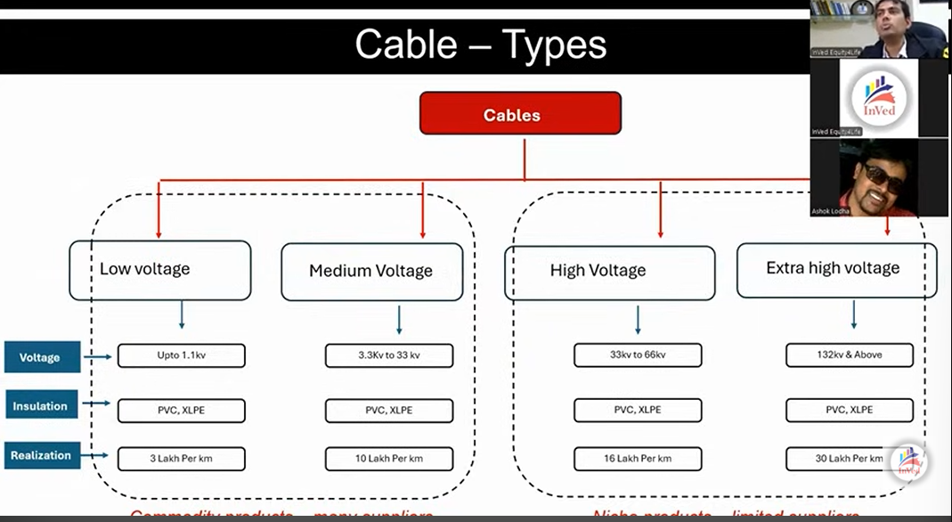

* + - Realizations are higher for EHV cables rated 132kV and above

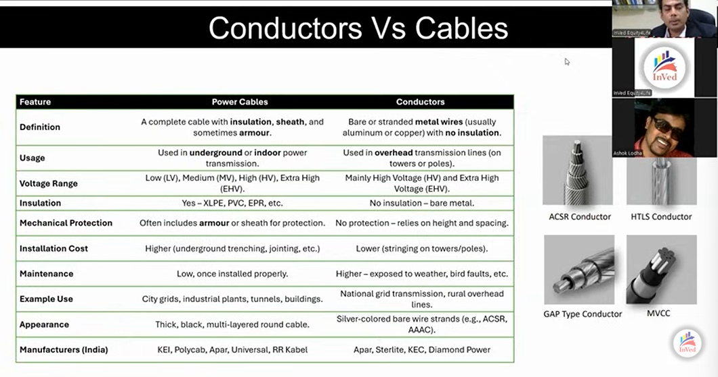

* + Analyzing w&c company

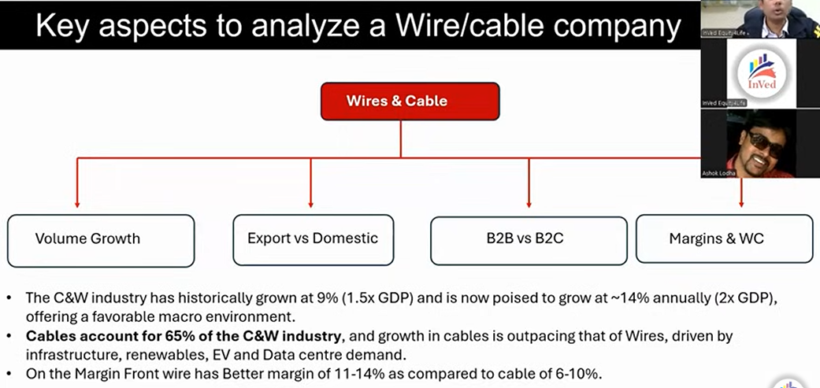

* + Volume growth matters more as metal prices can affect realizations but can be supported with higher volume growth. Structural growth at more than GDP. Cables account for more majority and are growing faster than wires. B2C yields better margins.
  + Companies:
    - Apar
      * World’s largest conductor manufacturer, with a third of going to exports especially to the US.
      * Capex at Rs. 1300 crore, with Rs. 800 being employed in cables segment; cables capex can double cable segment revenue.
      * Orderbook of Rs. 7,168 crore for conduct business, including 24% for exports; Rs. 1,836 crore orderbook in cables business.
      * Volume growth of 16.2%
      * Working capital and margins: 8-10%; working capital of 51 days.
    - Universal Cables
      * Predominantly in power cables, especially in EHV cables. Only company to have vertical continuous vulcanization capabilities, which can also help manufacture EHV HVDC cables. Attractive as HVDC capex picks up. Story of right place at right time.
      * Capex of Rs. 525 crore
      * Export: 8.7% in FY25 to Europe, Australia, and Africa. USD 38 million order from Middle East to supply 400 kv EHV cable.
      * Pending orderbook of Rs. 2,945 crore as of Q2FY26.
      * Working higher as company takes EHV stuff as projects, similar to EPC business. Entering into EHV segment increases working capital days
    - Dynamic Cables
      * Specialty cable capex. Exporting to RoW at 10% of sales. Order book Rs. 720 crore, execution cycle of six to nine months. Working capital at 80 days, while margin at 10% (industry median).
    - RR Kabel
      * 73% of revenue from wires, with remaining of cables. Large capex in cables, primarily being into housing cables.
      * Export at 27%. 4000+ authorized dealers. Vol growth at 12%. Working capital at 54 days given B2C nature of business. EBITDA margin at 8%, given presence in low voltage cables.
    - Polycab
      * Capex Rs. 1200-1600 crore per year for next five years. 5-10 times FAT. Industrial and T&D cables.
      * Export at 7%, aiming to increase to 10% by FY30.
      * 4300+ dealers/distributors. Volume growth at 17-18%.
      * EBIDTA margins at 14-15%, with working capital at 54 days.
    - KEI
      * In LT, HT, and EHV cables.
      * Capex of Rs. 1400 crore.
      * Export at 14%, with long term target of 14-18% of revenue from exports.
      * 2100 dealers/distributors and 2000+ institutional customers.
      * Volume growth of 15%. EBITDA margin of 11% in W&C segment. Working capital higher at 89 days due to more institutional business.
    - P2P

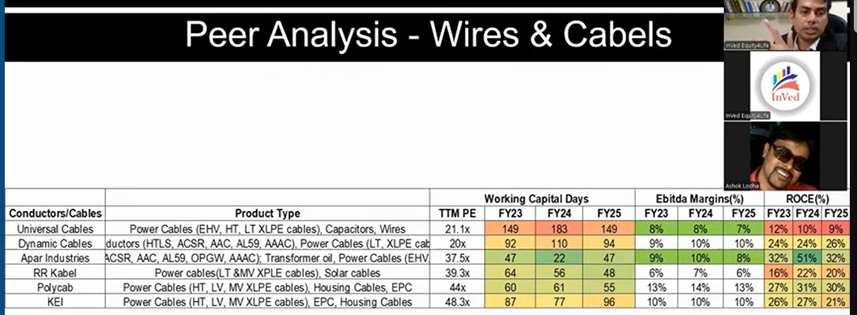

* + - Outlook

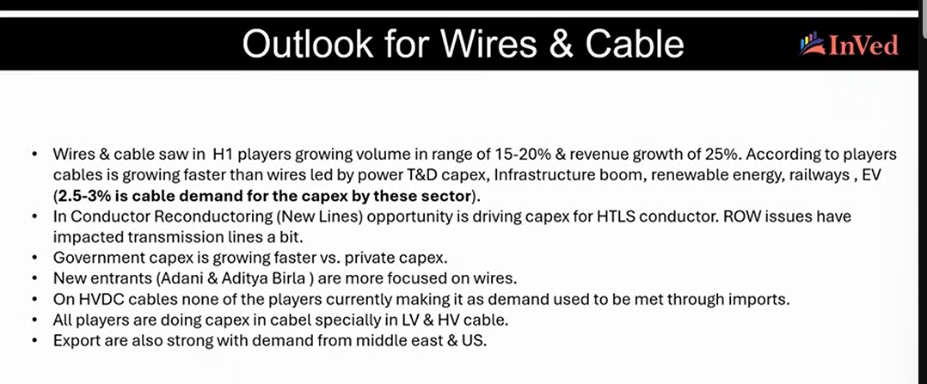

* + - * 2.5-3% of capex in T&D, infra, renewables, railways, and EV is for cables.
      * Reconductoring.
      * HVDC no one is making, but Universal can make it.
    - Strongest companies: APAR and Universal Cables.
* HVDC
  + FACTS
    - Required for converting AC to DC and vice versa, and maintaining the properties of electricity, such as frequency, voltage, current, etc. Semi-conductor based devices and can respond to issues in milliseconds compared to mechanical devices.
    - Helps avoid or mitigate fluctuations in frequency and voltage, such as voltage drops, thereby supporting grid stability.

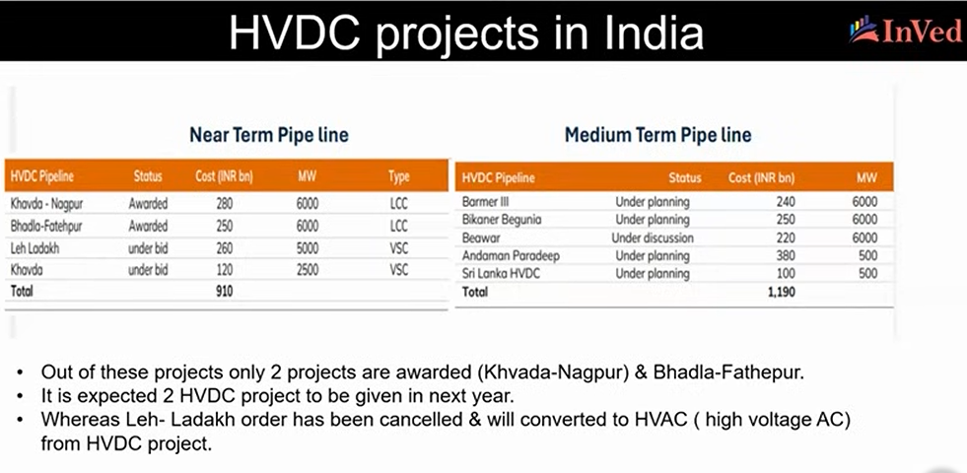

* + Aspects to analyze in HVDC company
    - HVDC Capability
    - Exports
    - Orderbook
  + Companies
    - Quality Power
      * Only listed Indian company that can provide HVDC and FACTS products. Primarily into reactor and coil products. Niche products. Partnered with Hyosung for GIS related instrument transformer.
      * Orderbook at Rs. 830 crore.
      * 65% revenue from exports, especially from Turkey.
      * Capex increasing global coil products by 9x and backward integration into magnet wires.
    - GE Vernova
      * Works across engineering, products, solutions, and services.
      * Orderbook of Rs. 13105 crore. Book to bill of 3x. Order inflow of Rs. 1600 crore in Q2FY26.
      * Export: 28% revenue. Export orders mainly from global parent. Current orderbook has 35% exports.
      * Capex of Rs. 800 crore, exceeding current gross block, across transformer and reactor, GIS products, reactors, and bushing.
      * Only negative is no order for HVDC products; still, company has capability to manufacture them.
    - Hitachi Energy
      * Most exposed to HVDC theme. Company can do both LCC and VSC technology in HVDC.
      * Orderbook of Rs. 29,412 crore. Book to bill of 4.6x. order inflow of Rs. 2217 crore. Of this, Rs. 10000 crore is HVDC orderbook.
      * Exports between 25-30%, with better margins in exports.
      * Capex of Rs. 2000 crore across large and small power transformers, dry and traction transformers, HVDC systems, components, and network control solutions.
      * 15-20% data center capex can be addressable market.
    - CG Power
      * Power and industrial systems, including power transformers (higher kV side business) and switchgears.
    - Siemens

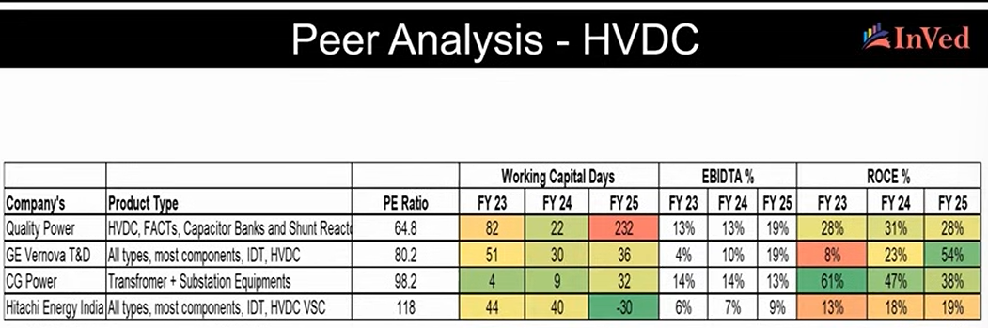

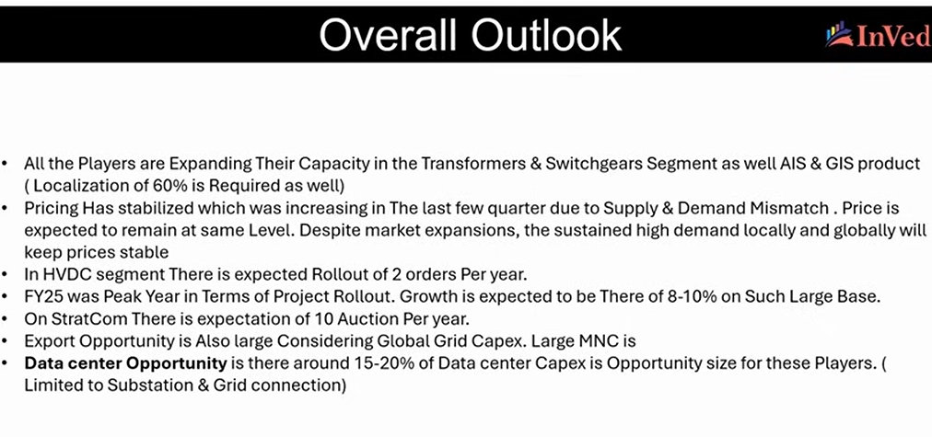

* ETC. 2025. Power Systems Transformation.
  + Balancing electricity supply and demand across days, weeks, months, and years across geographies with different energy resource endowments and climate conditions can drive differences in extent of absorbability of variable renewable generation, grid size, and investment and regulation needs.
  + Solutions to this balancing challenge include flexible dispatchable generation, innovative grid technologies, long-distance transmission, energy storage, and demand-side flexibility.
  + Total system costs are likely to be lower for low latitude sun belt countries with large solar resources and lower season variability, including lower than today’s fossil based systems. Shorter duration needs would help keep costs lower.
  + Although slightly higher than sun belt countries, total system costs are also likely to be relatively lower for high latitude wind belt countries. Longer duration needs would increase system costs.

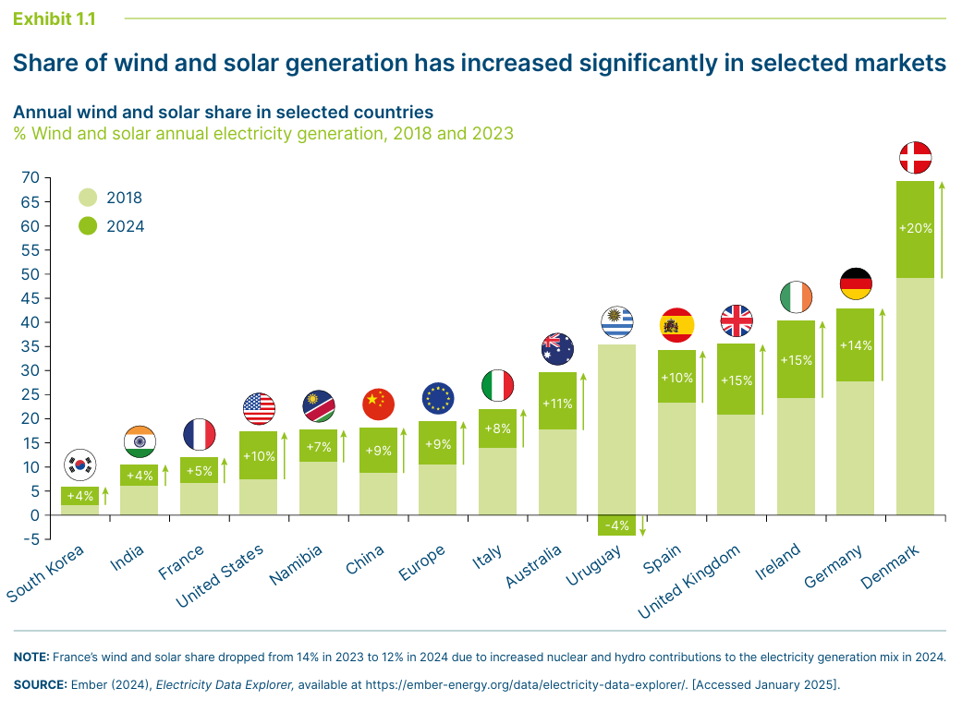

Systems across the world are at different levels of proportion of solar generation. Solar generation can meaningfully go up in relatively more sunny parts of the world. The maximum amount of generation variable renewable generation grids can handle can vary but may entail higher costs towards both 1) ensuring grid stability and safety, while 2) matching supply and demand across timescales.

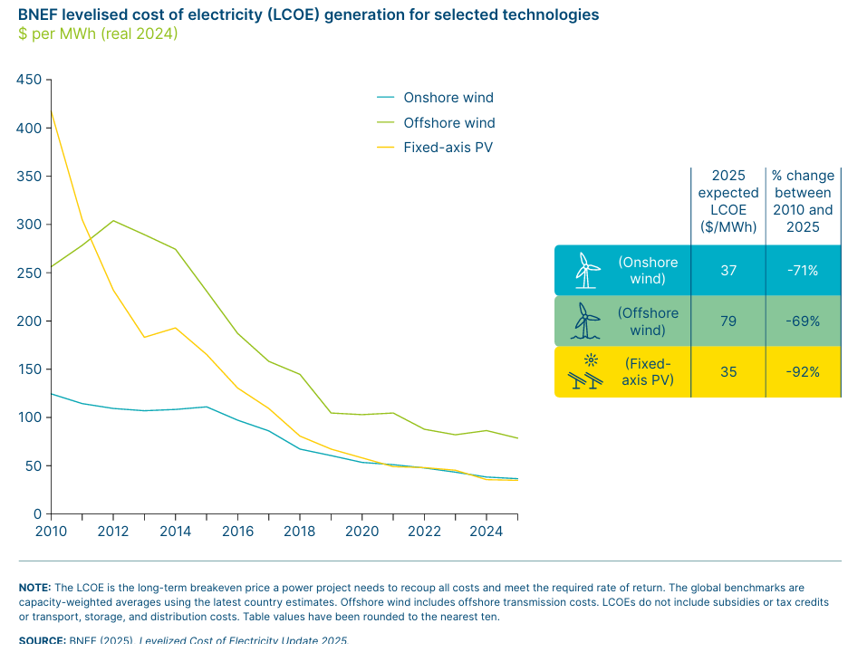

Technical balancing challenges exist: frequency response, inertia, voltage support, and black start (i.e., restarting the grid after a blackout) capabilities.

1. *Maintaining system inertia* helps ensure grid stability and frequency response. Instantaneous supply and demand balance is crucial to maintain frequency within an acceptable range. Imbalance can create frequency deviations, tripping the generation units (e.g., Spanish blackout in 2025). Earlier mechanical generation technologies based on turbines provided these two functions. Newer technologies like grid forming inverters (can independently establish and regulate grid frequency; and also offer black start and recovery capabilities) and synchronous condensers (large rotational devices energized using the grid; relatively more capital intensive) are being used to replicate these functions. Battery storage can also provide all four required capabilities, especially when combined with advanced power electronics.
2. *Controlling voltage* is crucial to ensure that it remains withing the specified range to ensure system stability. Technologies such as static var compensators (SVC), static var generators (SVG), static synchronous compensators (STATCOM), and Thyristor-controlled series capacitors (TCSC) are used for this now.
3. *Wind and solar systems stay connected during and after faults without tripping*. Appropriate standards for high (HVRT) and low voltage ride-through (LVRT) capabilities, and rate of change of frequency (RoCoF) for the grid can help address this. RoCoF standards ensure fault response and stability but need to now be more flexible to accommodate higher wind and solar generation shares.

Together, these technologies must be deliberately engineered into grid systems. In addition, real time monitoring and automated control strategies to ensure grid resilience and stability, and prompt response are crucial.

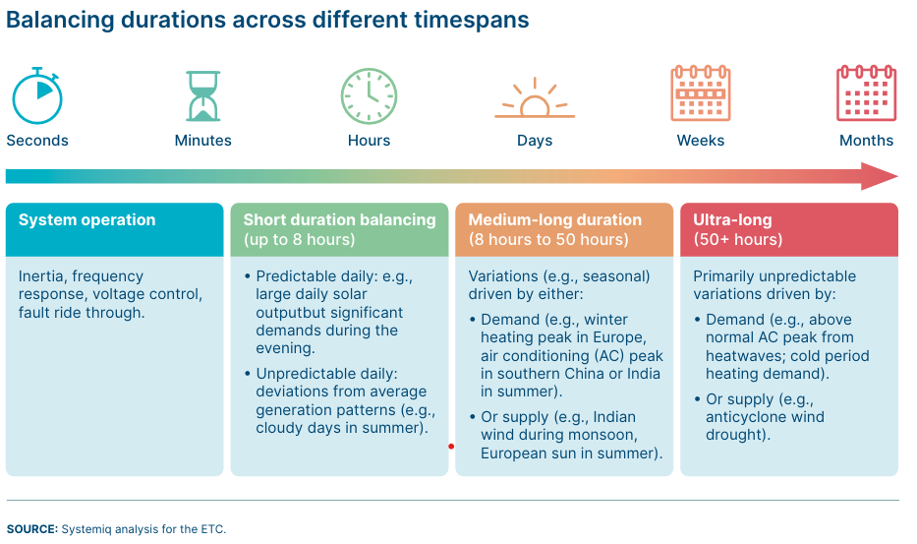

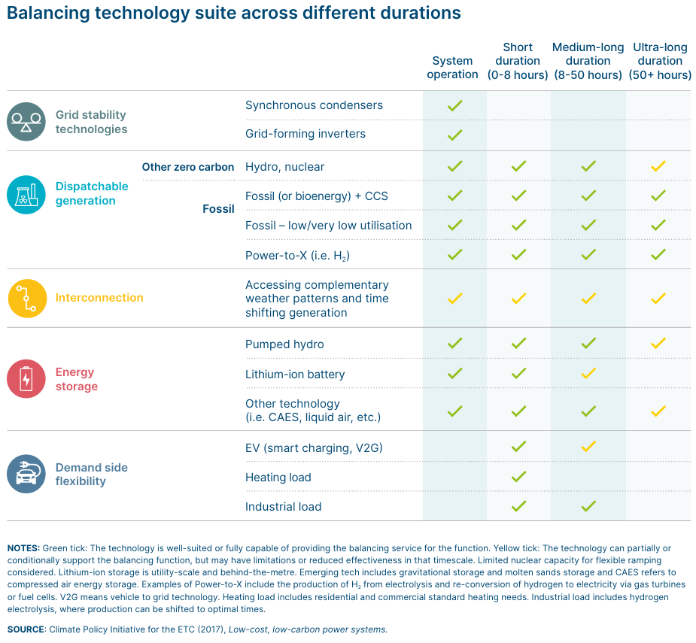

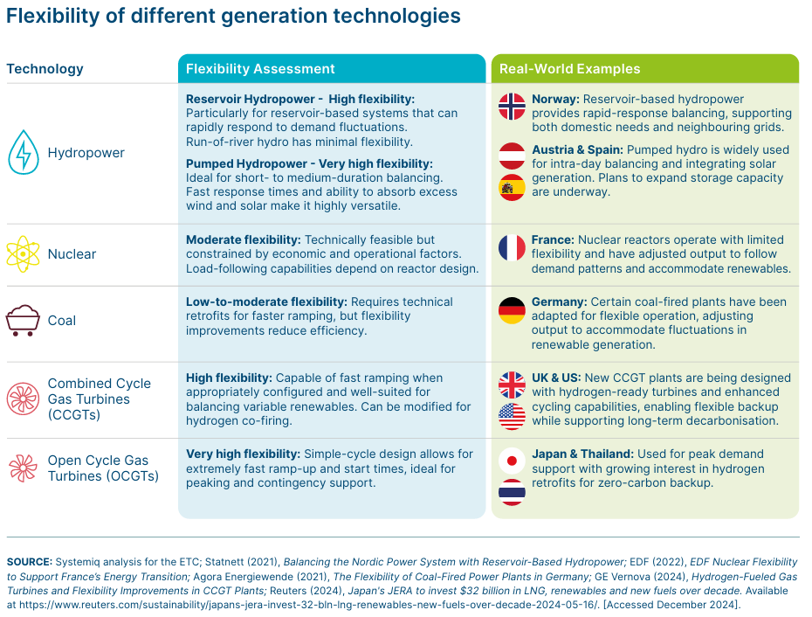

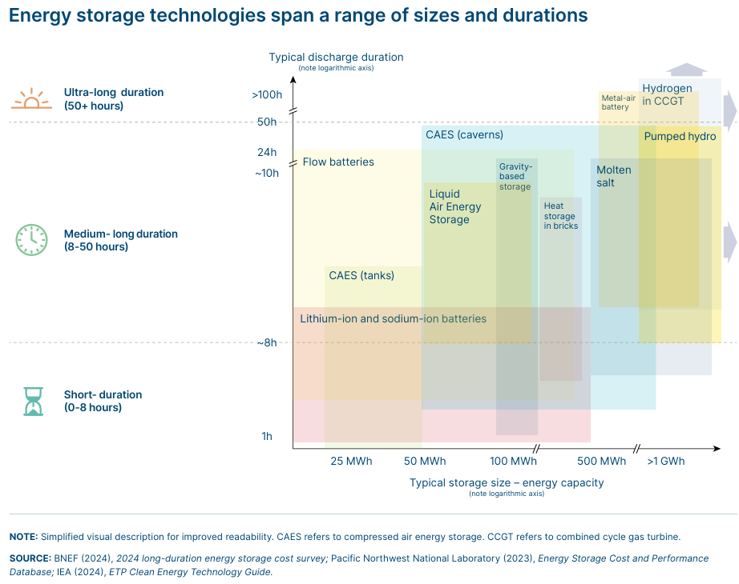

* Long distance transmission

HVDC lines more suited for long distance and cross-border transmission, while HVAC lines more suited for short distance and interconnection within well developed systems.

* Footnote 79: “Assuming over 1,000 km with high utilisation rates, e.g., 85%, for above ground projects, $3 per MWh per 1000 km for a 4,000 km overground line in India, to $10 per MWh per 1,000 km for a 1,000 km line in New England, USA. See Systemiq analysis for the ETC.”



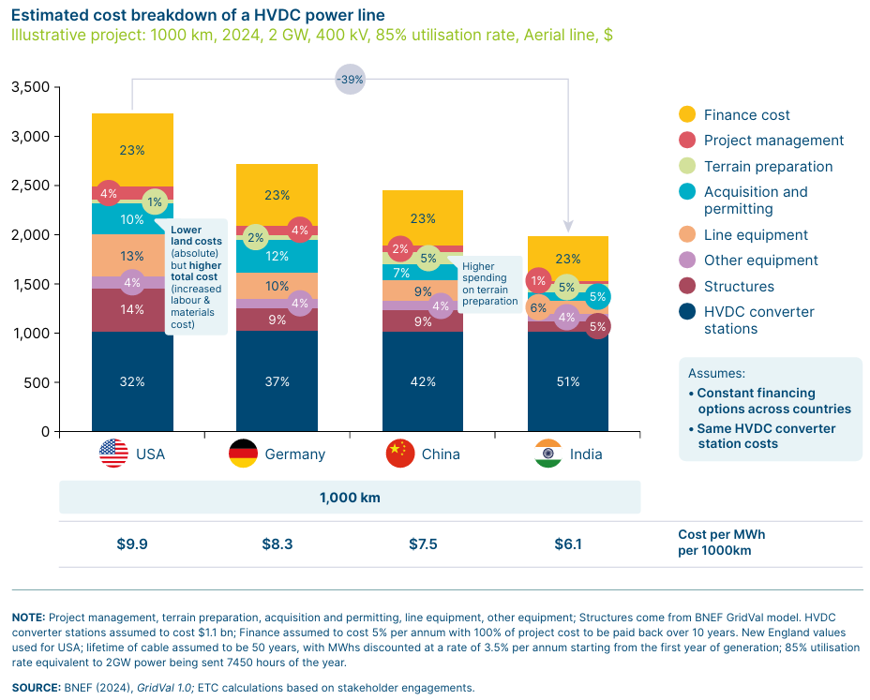

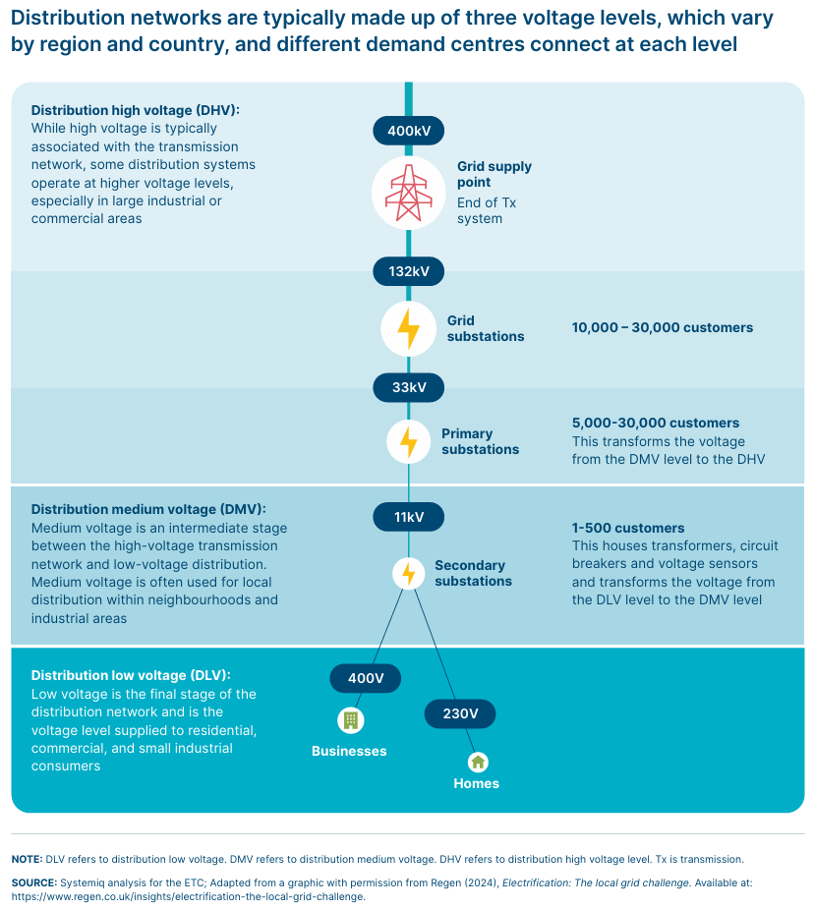

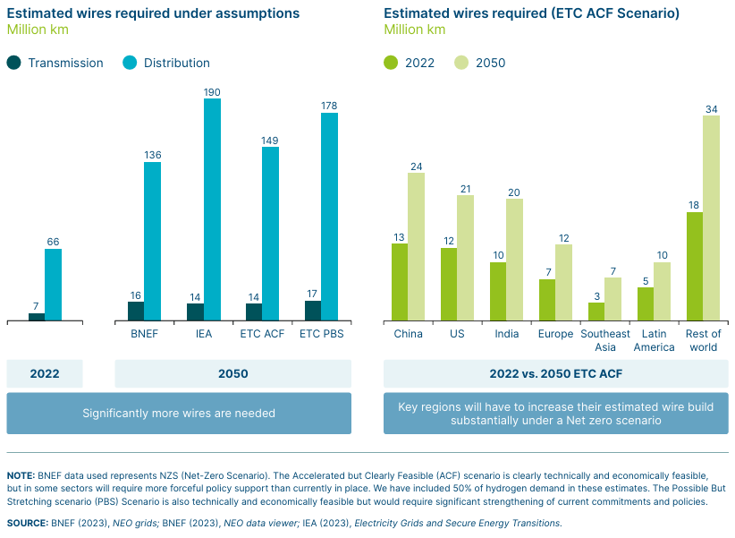

* “Both transmission and distribution grids will need to more than double in length. BNEF estimates the average costs per km for grid investments out to 2050 to be $1–2.5 million per km transmission and $0.2-0.3 million per km for distribution. Costs per km for the high voltage and power capacity transmission lines (plus related equipment) are thus on average around 7 times higher than for distribution networks (taking the midpoints of each range)”.

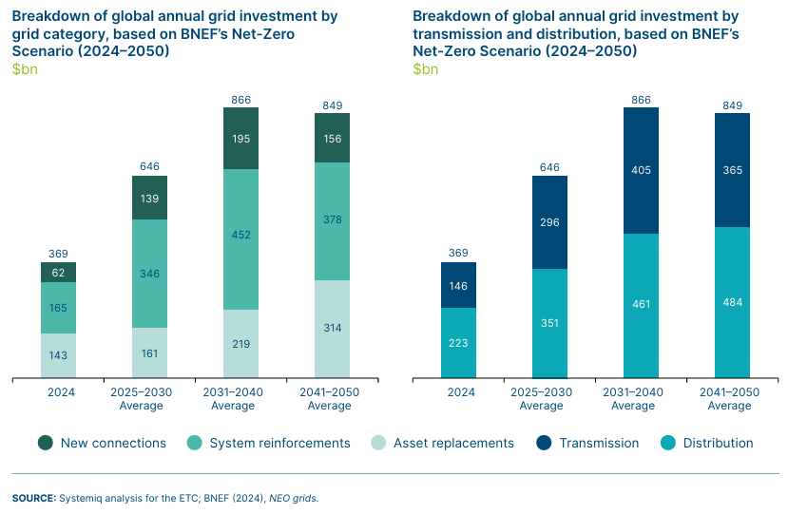

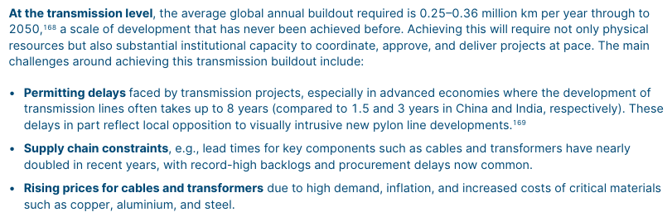

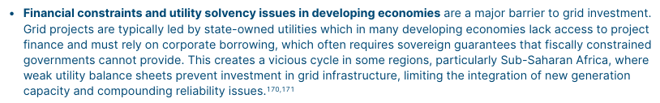

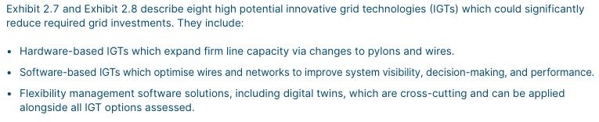



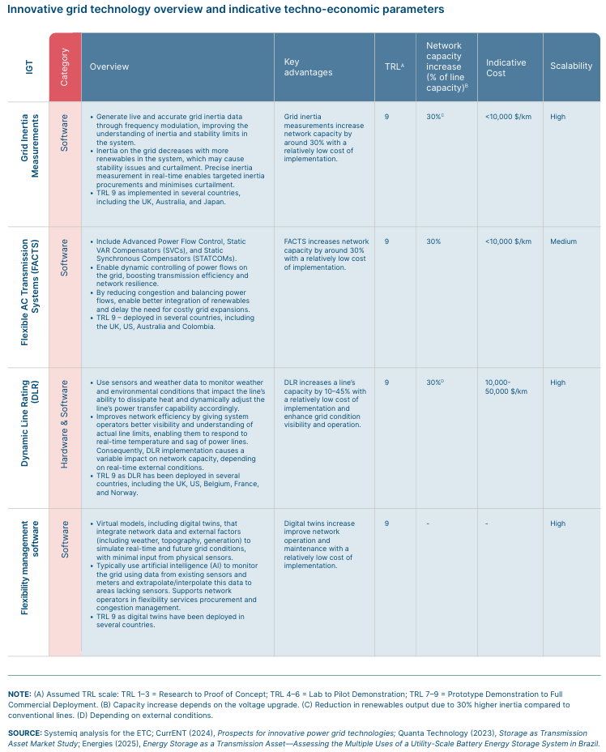

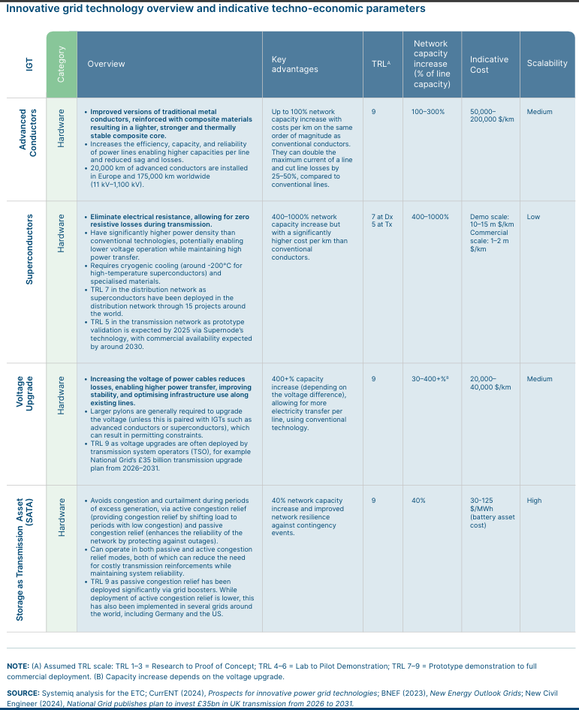

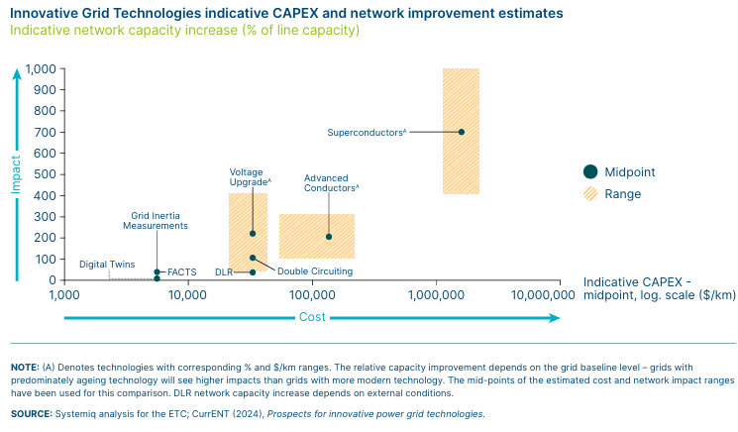

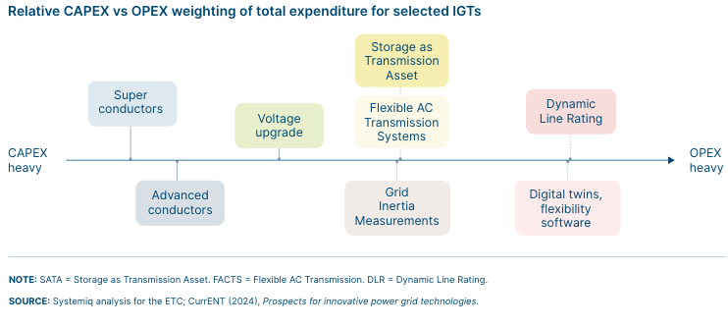

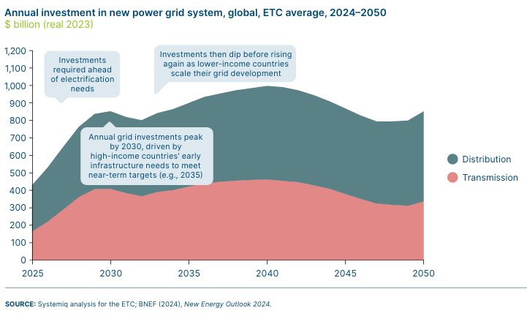

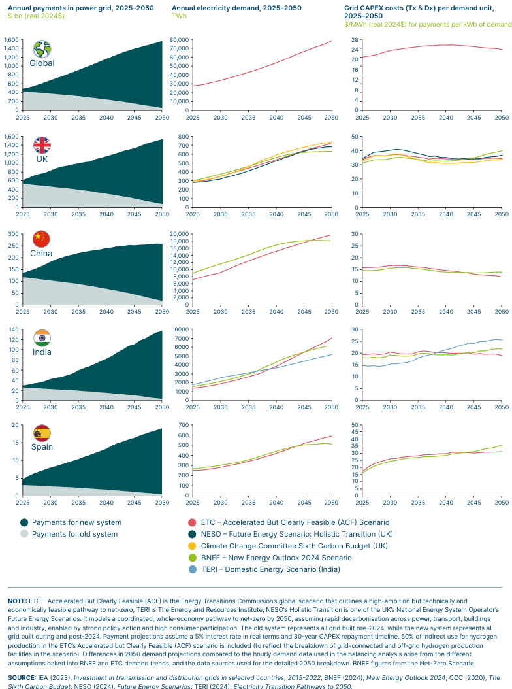

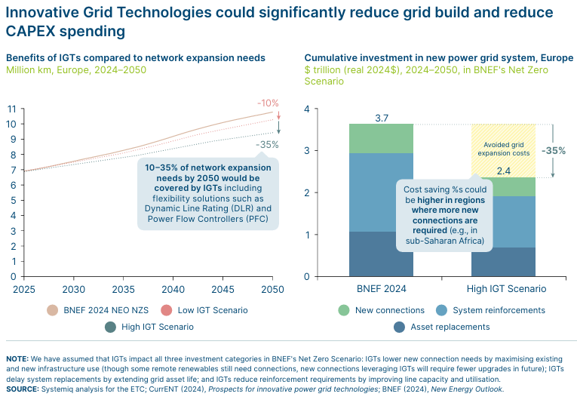

Source: ETC. 2025. Power Systems Transformation.

* Systemiq. 2025. Estimate of Grid Investment Impact. https://www.systemiq.earth/wp-content/uploads/2025/09/Estimate-of-grid-investment-impact-PIE.pdf

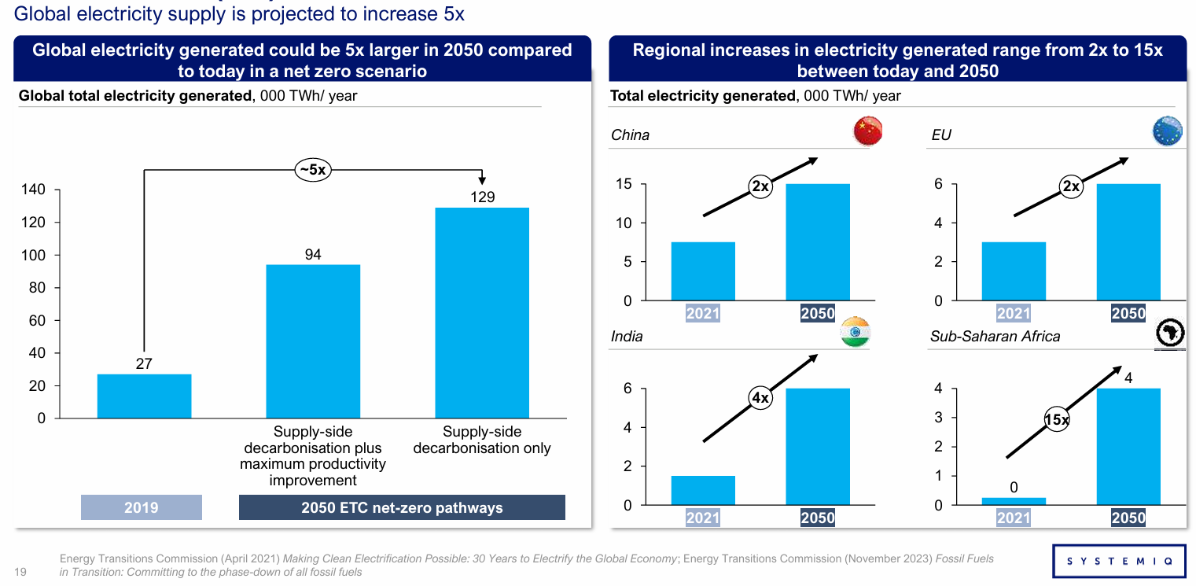

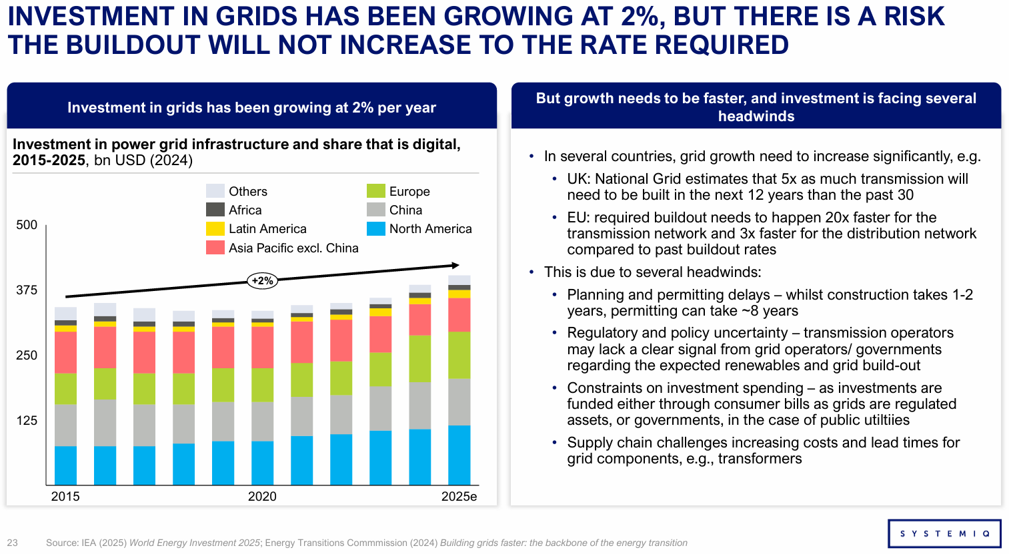

Source: Systemiq. 2025. Estimate of Grid Investment Impact.

RMI. 2024. Mind the regulatory gap.

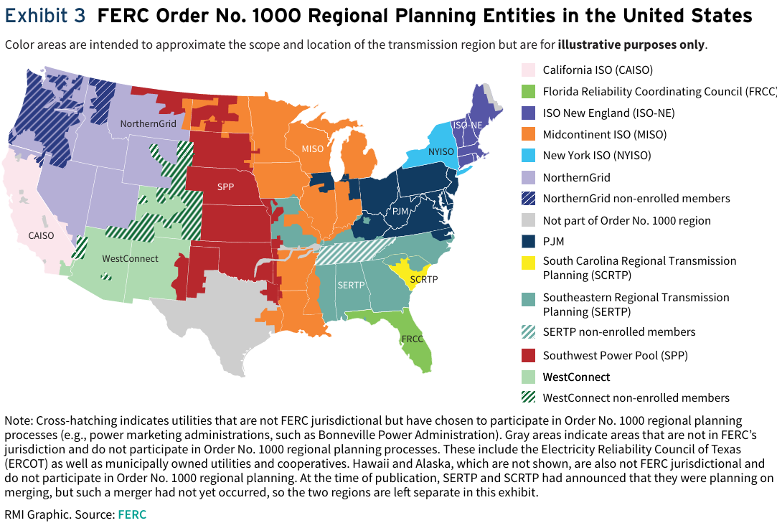

“In a region with an RTO or ISO, that entity is responsible for independently operating the transmission system and ensuring open access to it for all qualified parties. In a region without an RTO or ISO, the responsibility of operating the grid is divided among several utilities in the region and the regional planning entity serves as a forum for coordination among individual utility planning efforts.”

“For example, in PJM, out of the $71.8 billion spent on Supplemental projects since 2005, 66% has gone to projects associated with the Equipment Material Condition, Performance, and Risk driver, compared to 16% on Customer Service, 13% on Operational Flexibility and Efficiency, 3% on Infrastructure Resilience, and 1% on Other (about 2% had no driver listed). For more information, see “Transmission Cost Planner,” PJM Interconnection, accessed September 30, 2024, https://tcplanner. pjm.com/tcplanner”.

“GETs are a suite of technologies that can help extract more capacity from the grid for less money, including dynamic line ratings, topology optimization, and advanced power flow control. Advanced conductors are materials that can enhance the carrying capacity of power lines. For more information on these technologies, please refer to Russell Mendell, Mathias Einberger, and Katie Siegner, “FERC Could Slash Inflation and Double Renewables with These Grid Upgrades,” RMI, July 7, 2022, https://rmi.org/ferc-could-slash-inflation-and-double-renewables-grid-upgrades/.”

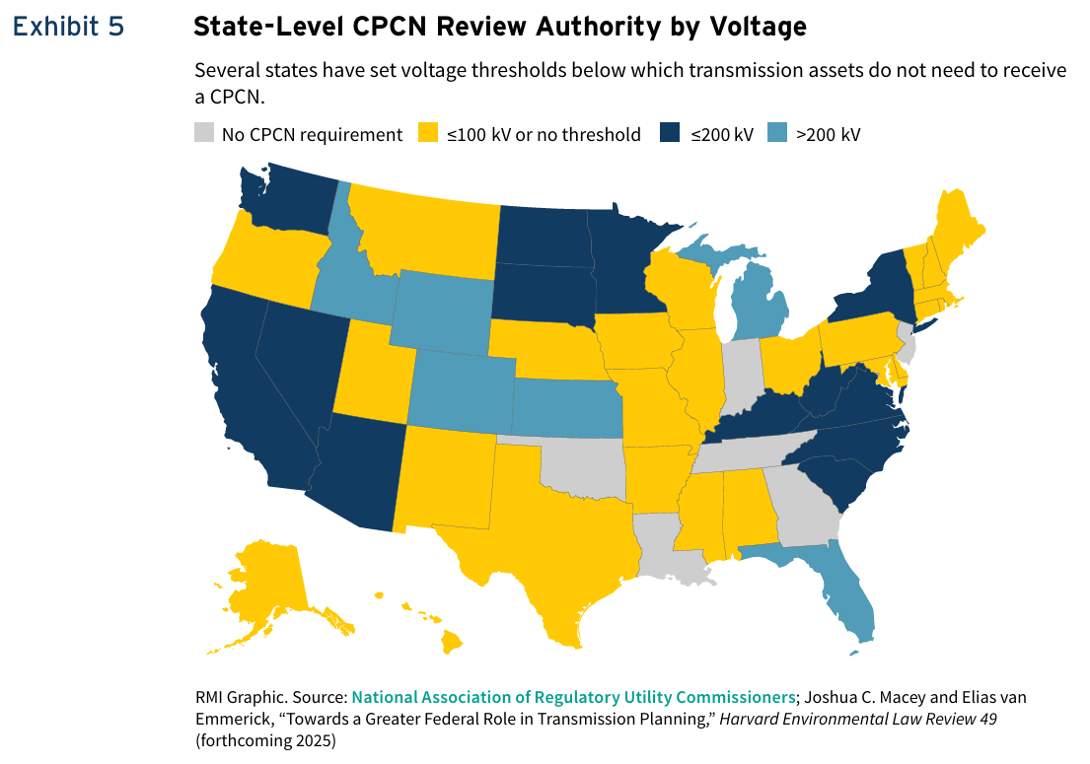

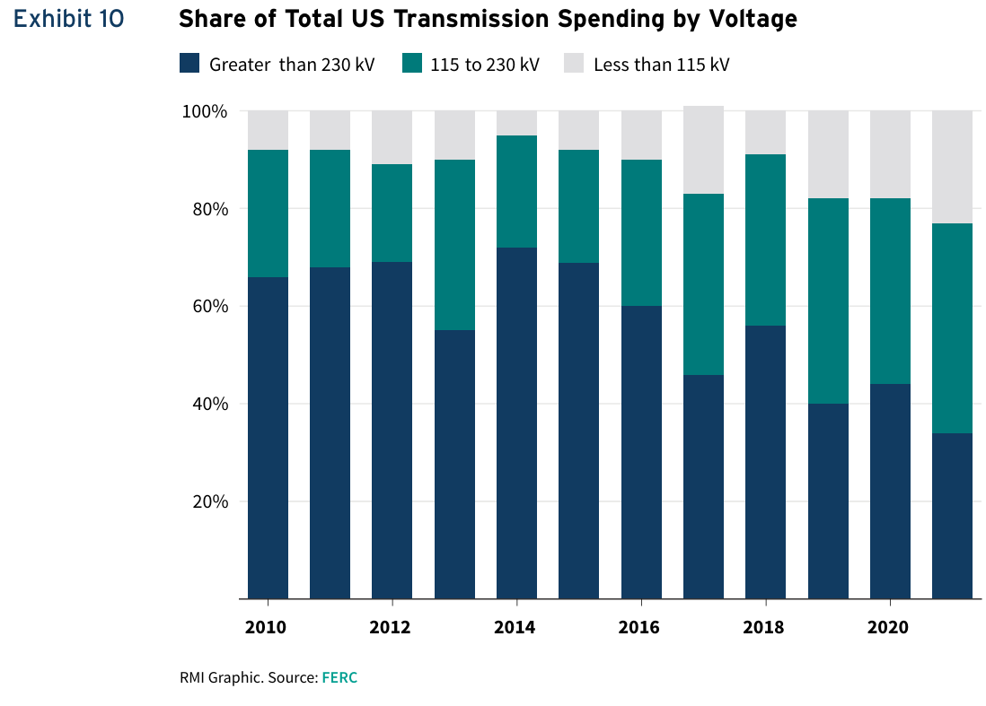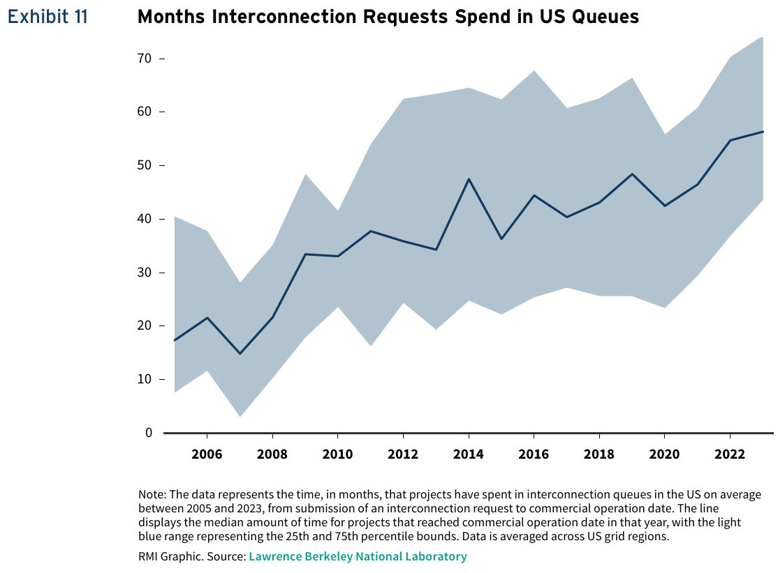

FERC. 2023. National Transmission Needs Study.

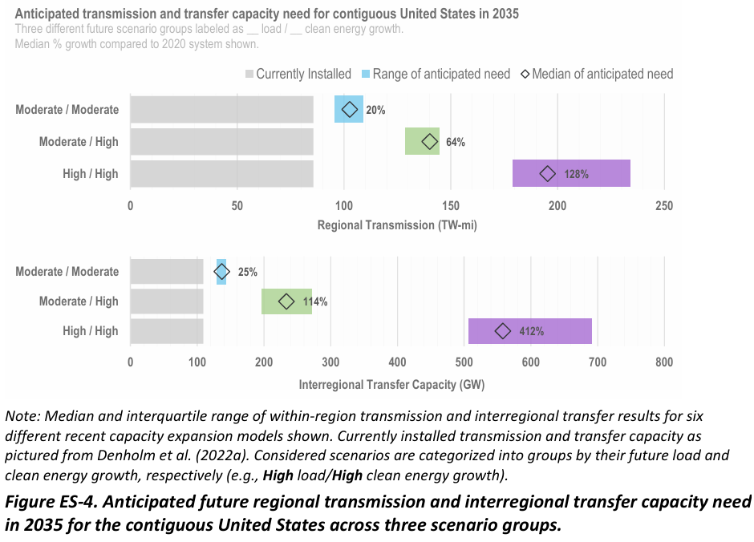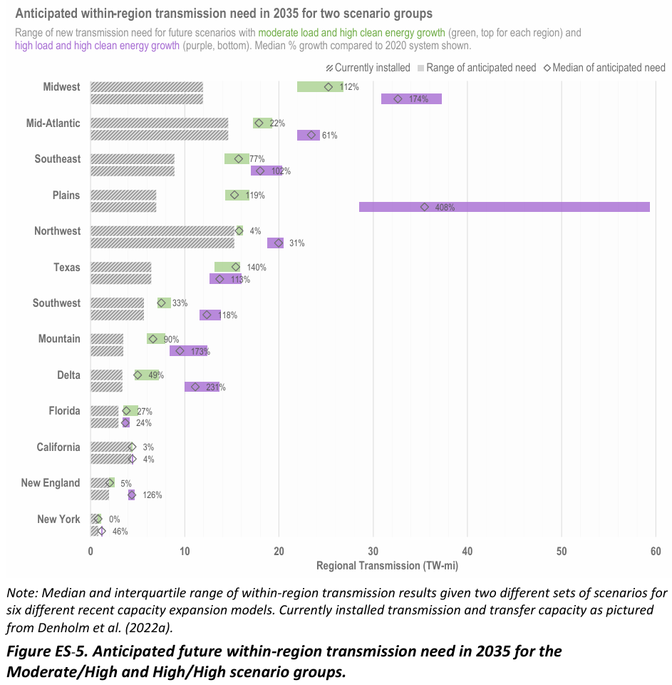

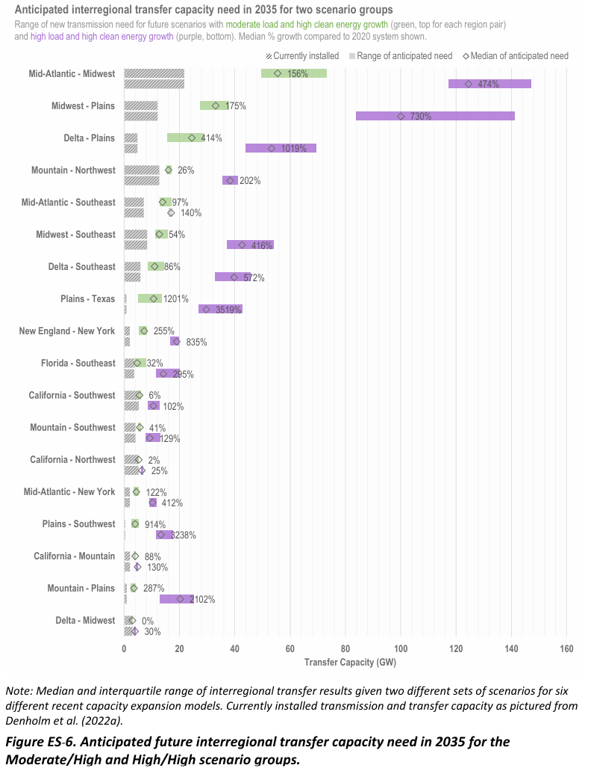

Kalpataru. QIP Placement Document.

“ENTSO-E’s Ten-Year Network Development Plan (“TYNDP”) shows that in the next seven years the cross-border transmission infrastructure should double, with an additional 23 GW capacity being incorporated by 2025 and a further 64 GW by 2030.”

RMI. 2024. Mind the regulatory gap.

“For example, in PJM, out of the $71.8 billion spent on Supplemental projects since 2005, 66% has gone to projects associated with the Equipment Material Condition, Performance, and Risk driver, compared to 16% on Customer Service, 13% on Operational Flexibility and Efficiency, 3% on Infrastructure Resilience, and 1% on Other (about 2% had no driver listed). For more information, see “Transmission Cost Planner,” PJM Interconnection, accessed September 30, 2024, https://tcplanner. pjm.com/tcplanner”.

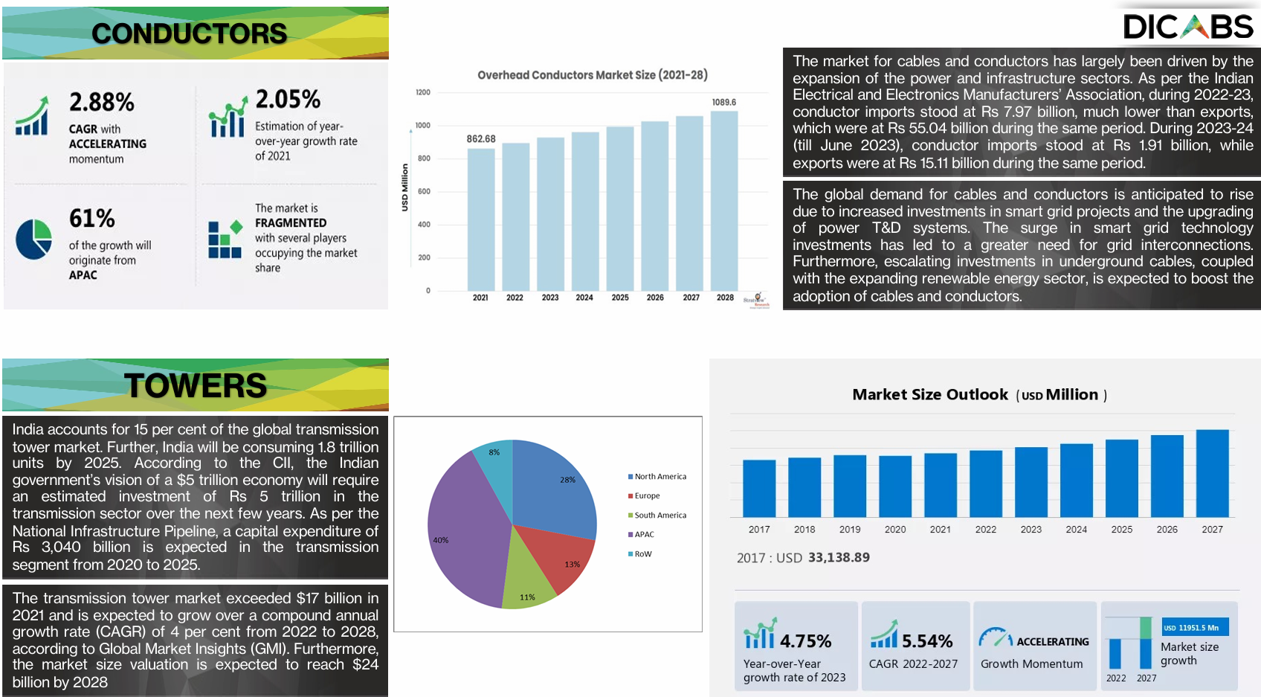

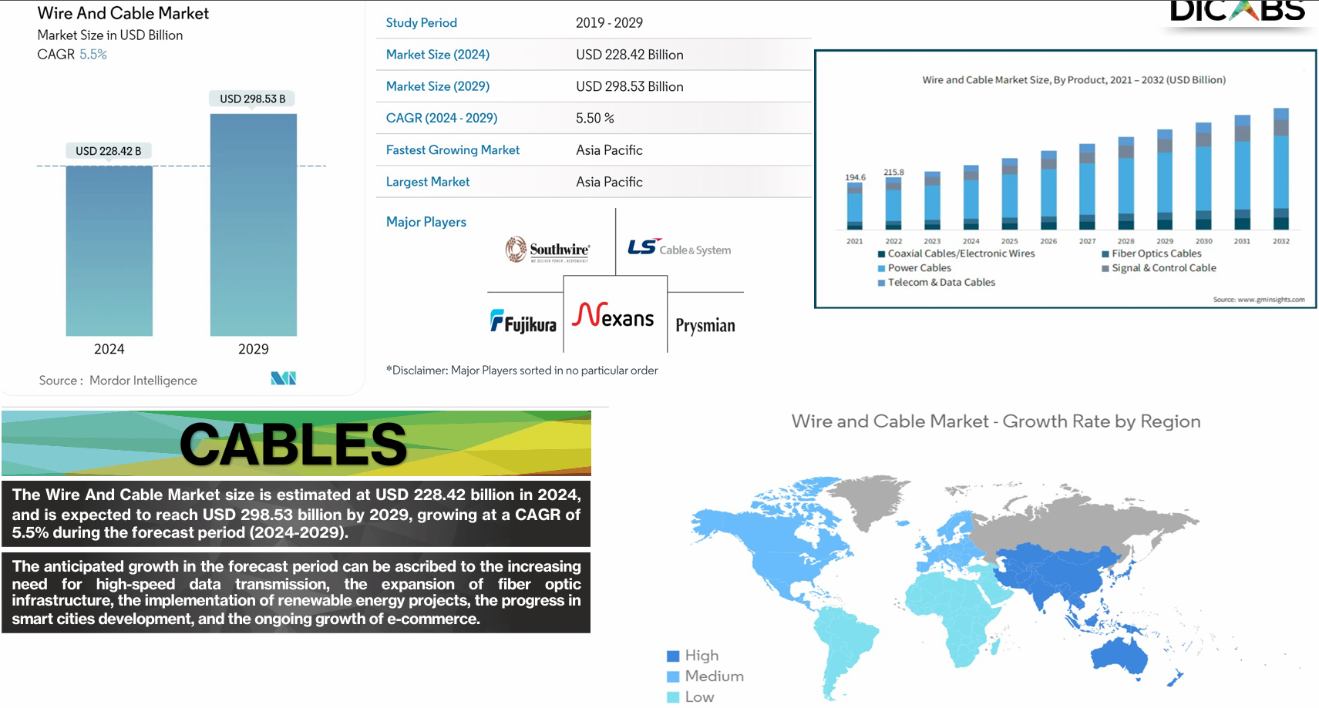

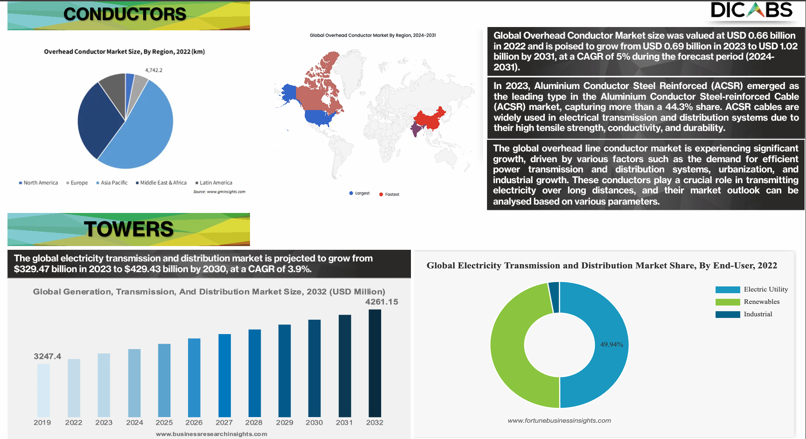

Conductor margins:

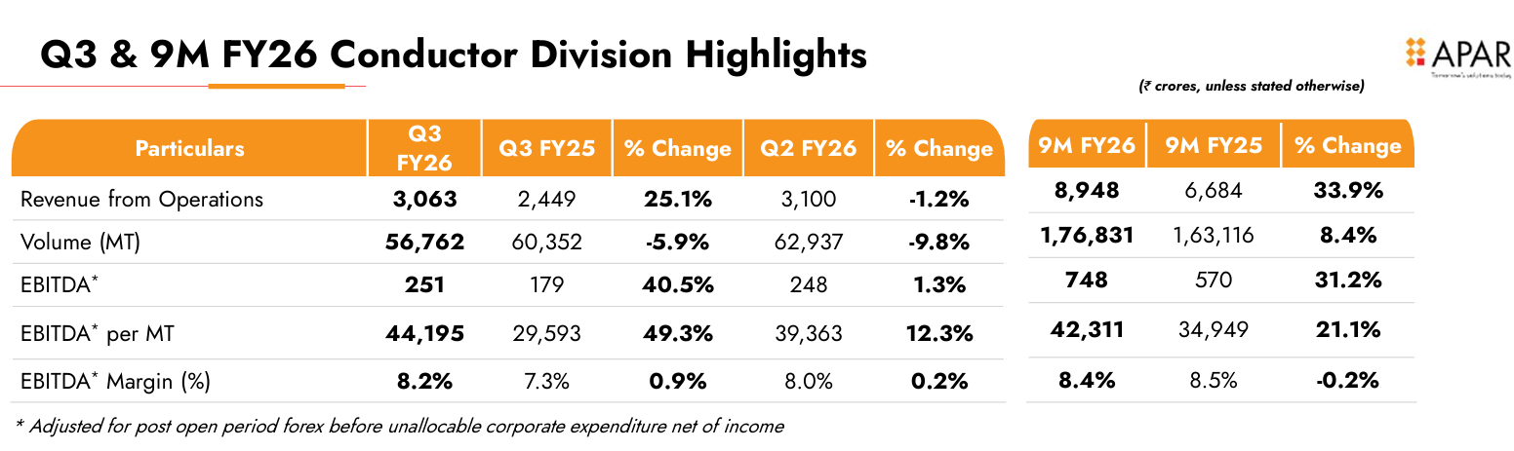

Cable margins:

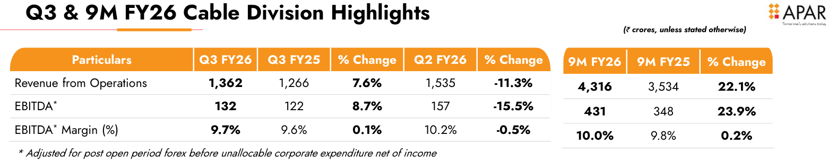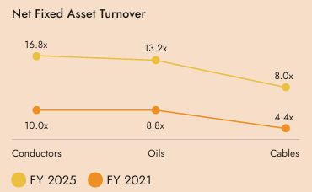

Source: APAR. 2025. Annual Report.

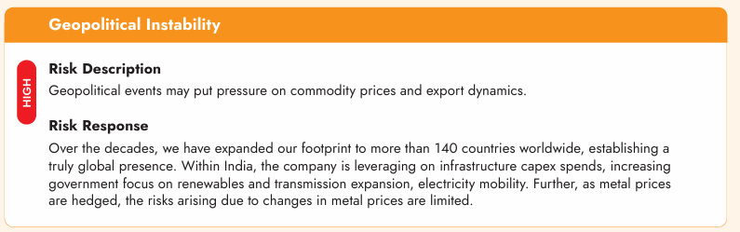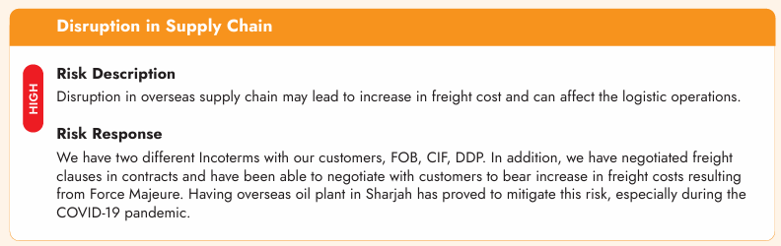

Need to figure out the annual cost of hedging against forex and metal prices (for aluminum and copper).

Metal hedging: Pricing based prompt hedging formula. Pass on both gains and losses from hedging to the customer.

Forex hedging: Forward contracts and appropriate hedges. Contractual agreements to pass on forex gains/losses to the customer.

Cost pass through policies need to be considered for cost increases from freight and other aspects.

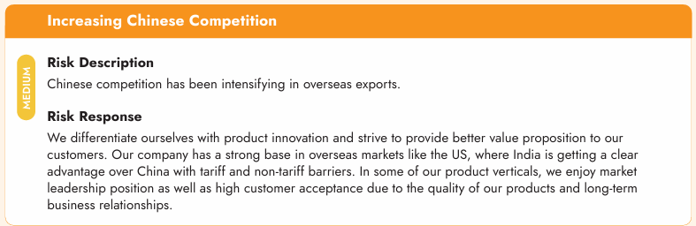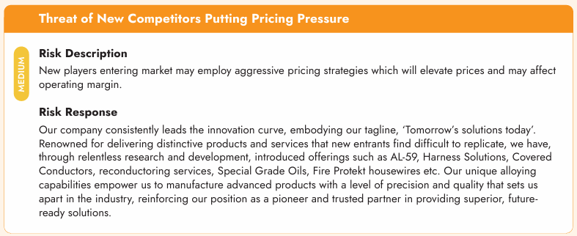

Capital allocation risks

Source: APAR. 2025. Annual Report.

How to improve margins: Focus more on high voltage products (higher kV) and HVDC, lower EPC and more product sales, more technologically better products (HTLS, ACCC, or power conductors with optical cables), reconductoring, JV for technology transfers to lower R&D costs and risks.

Work on certification and auditing from international regulators. Focus on regulators which have closer regulatory structures to that in the aspirational target end market, which is the US. Work with partners from these jurisdictions to gain necessary technical certifications. Also work with OEMs to get their certifications for products. Finally, ISO certifications for facilities and manufacturing processes to gain customer confidence and ensure quality.

If conductor market is the focus, then target contracts with aluminum manufacturers for cheaper procurement.

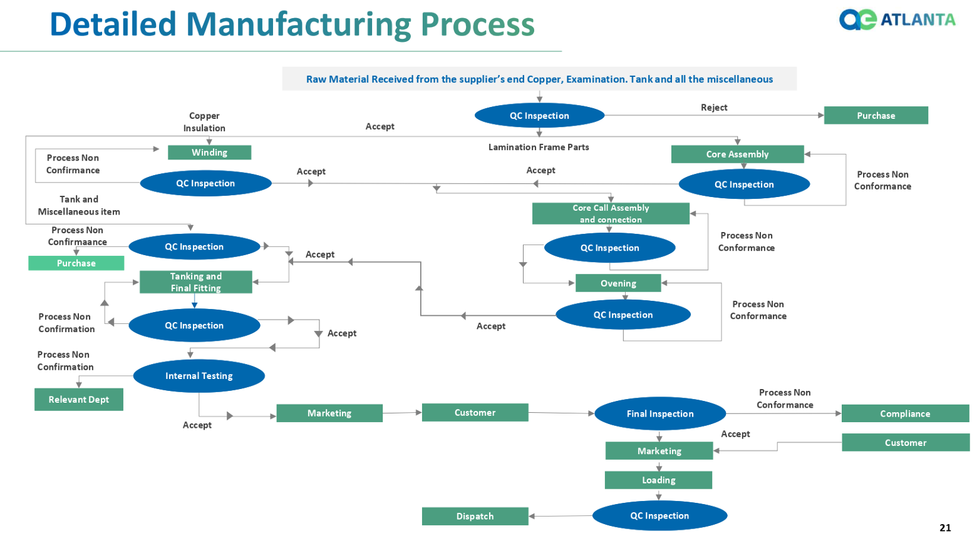

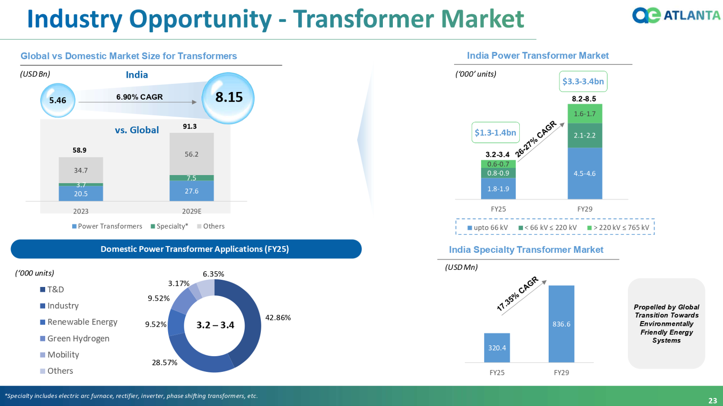

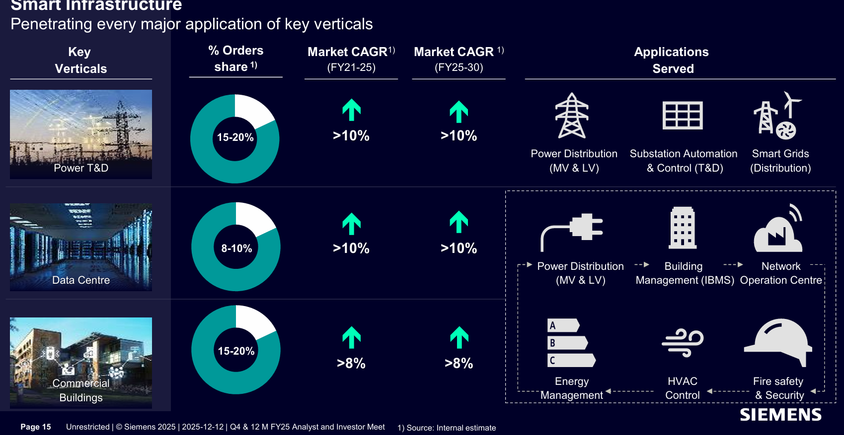

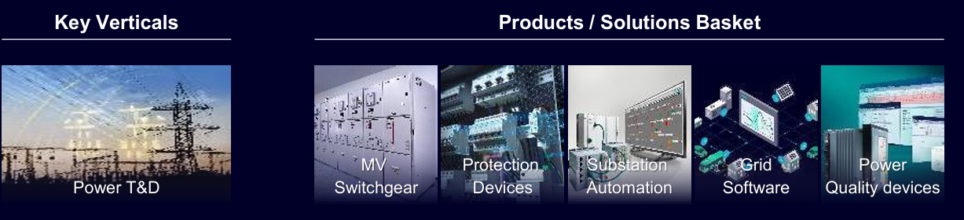

Source: SIEMENS Energy presentation.

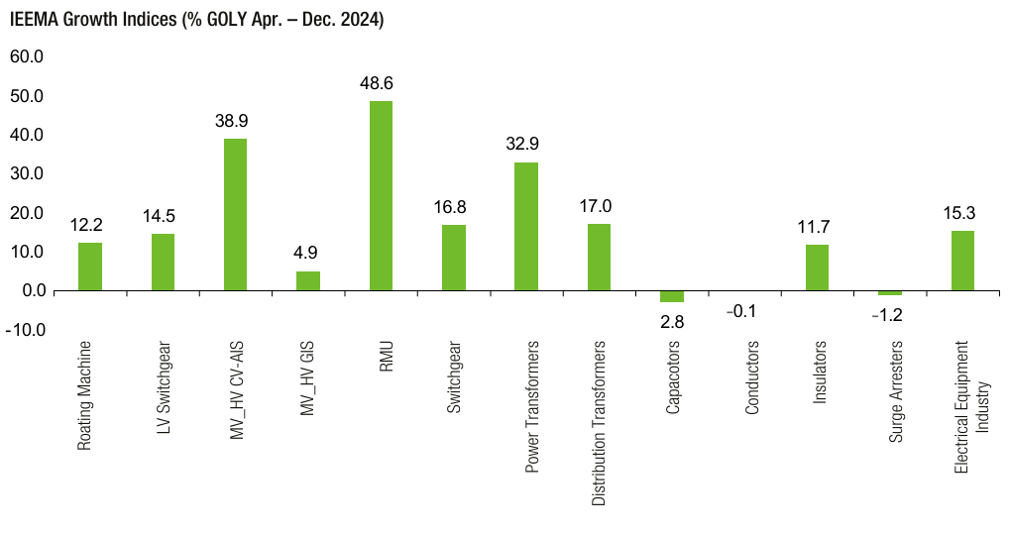

Source: CG Power. 2025. AR.

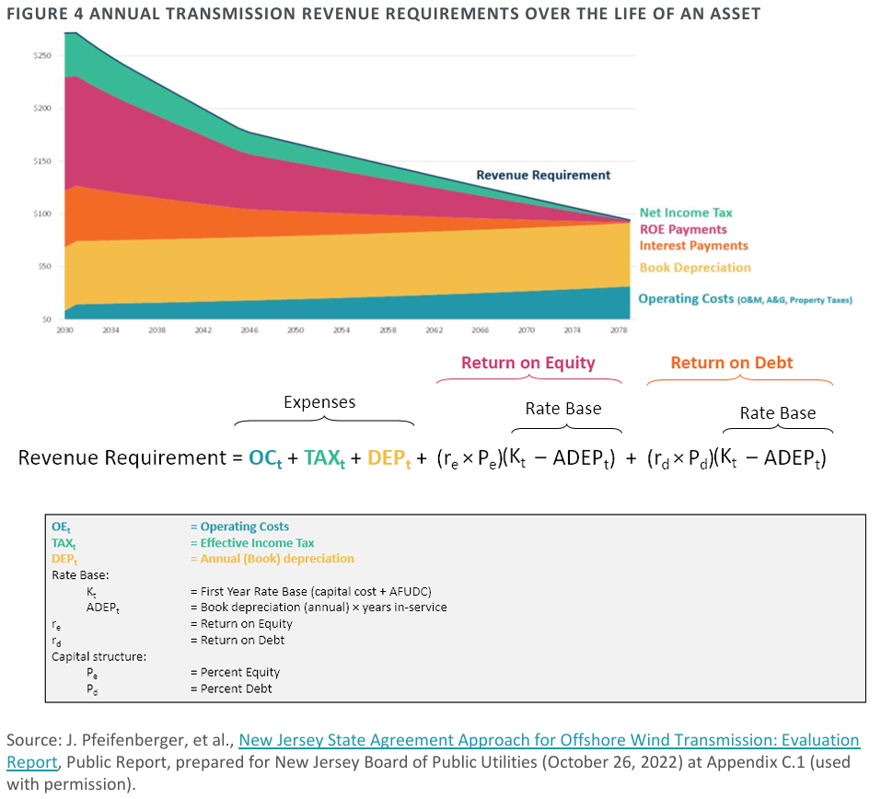

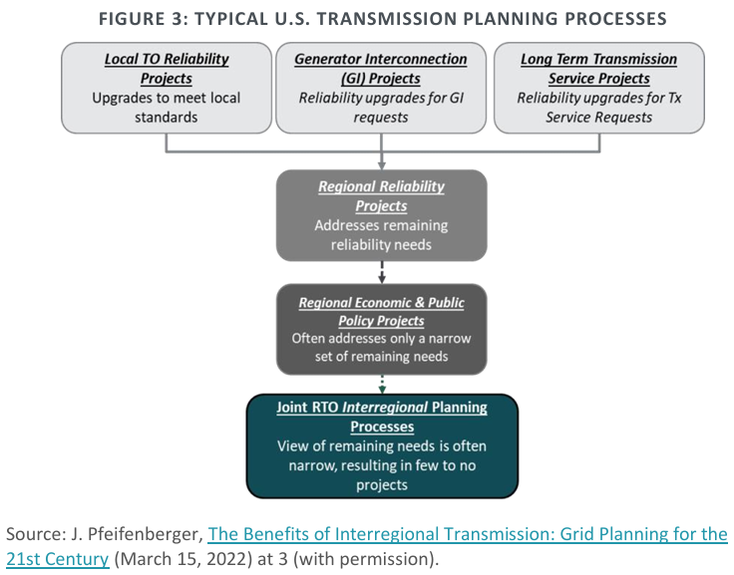

Source: Joe DeLosa III, Johannes P. Pfeifenberger, Paul L. Joskow. 2024. Regulation of Access, Pricing, and Planning of High Voltage Transmission in the U.S.

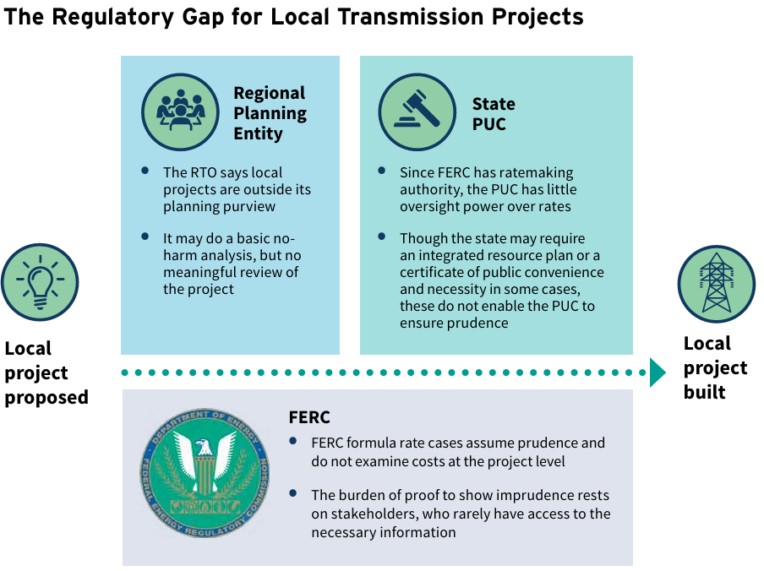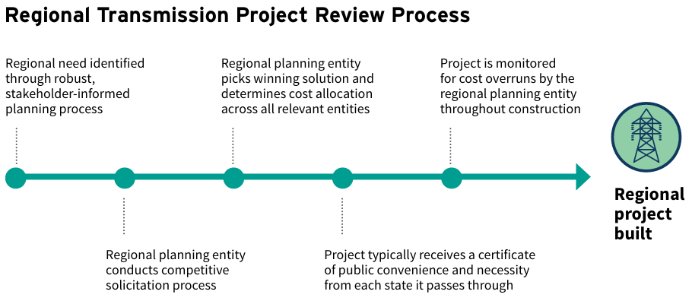

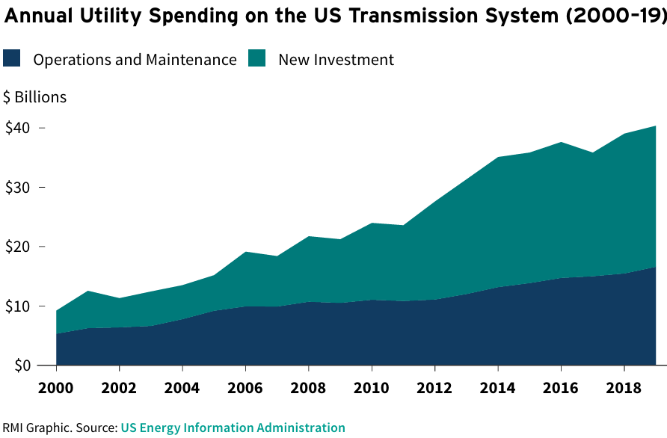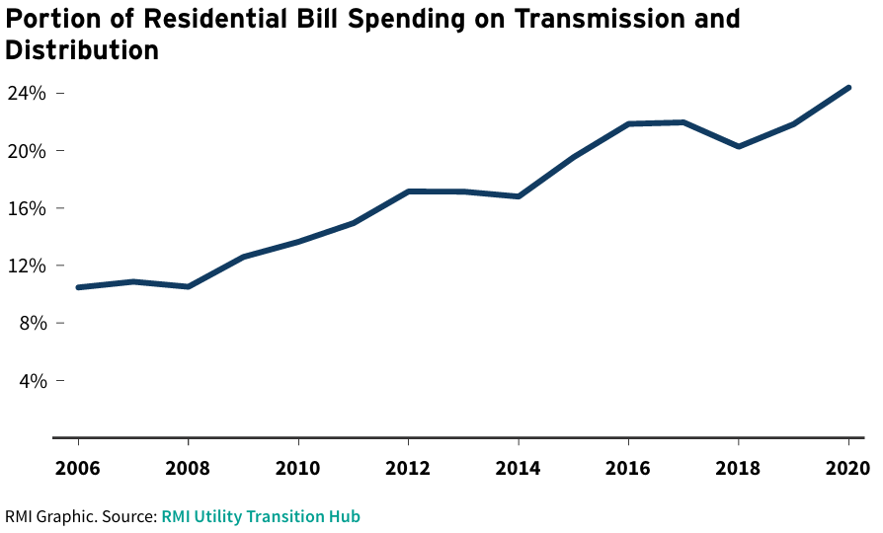

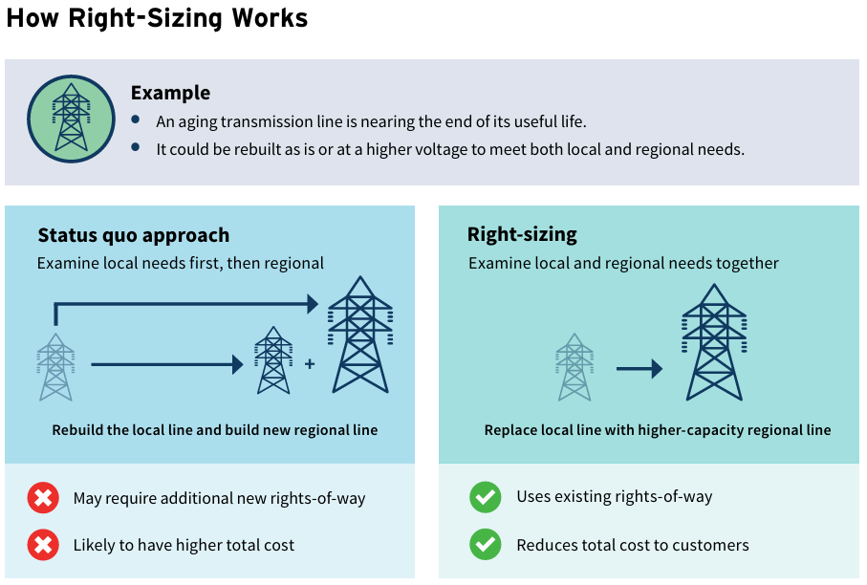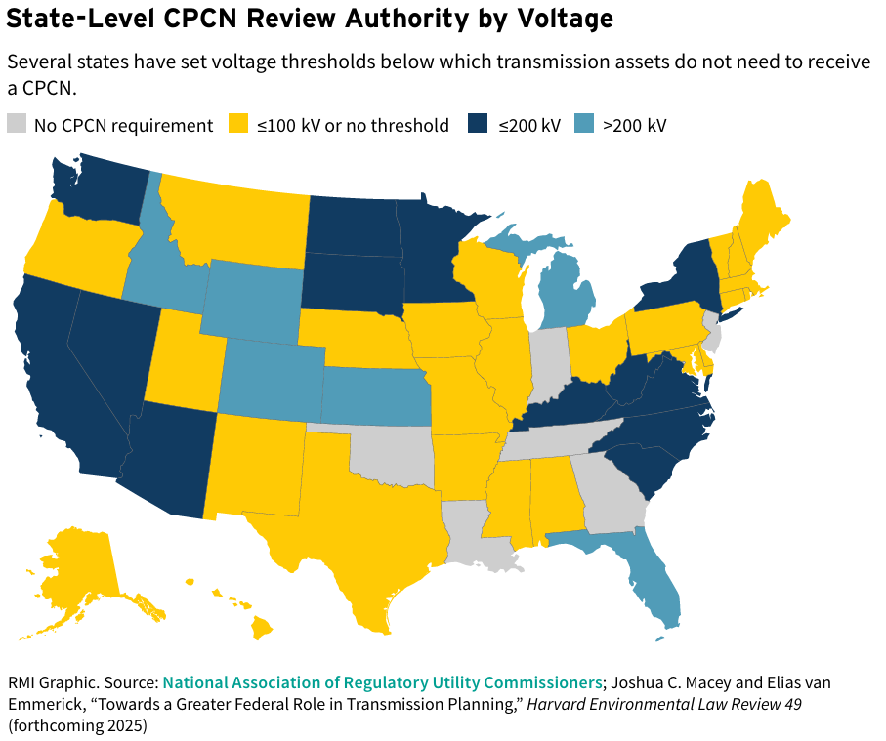

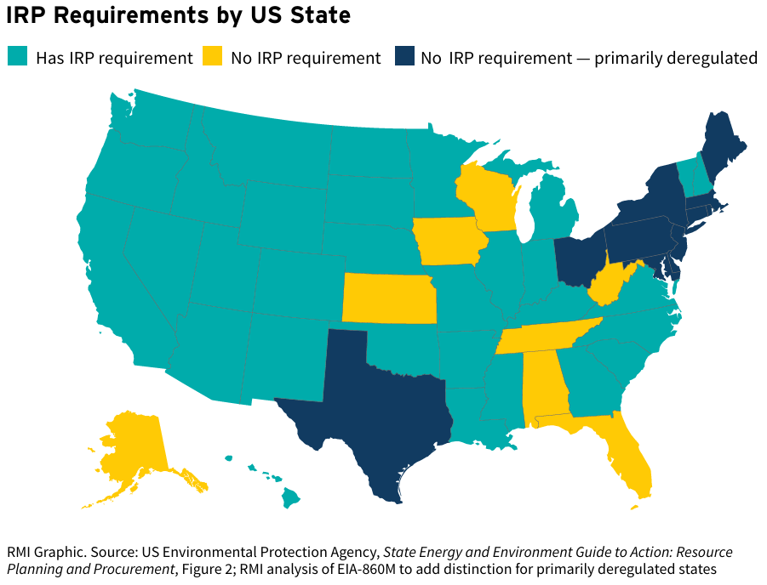 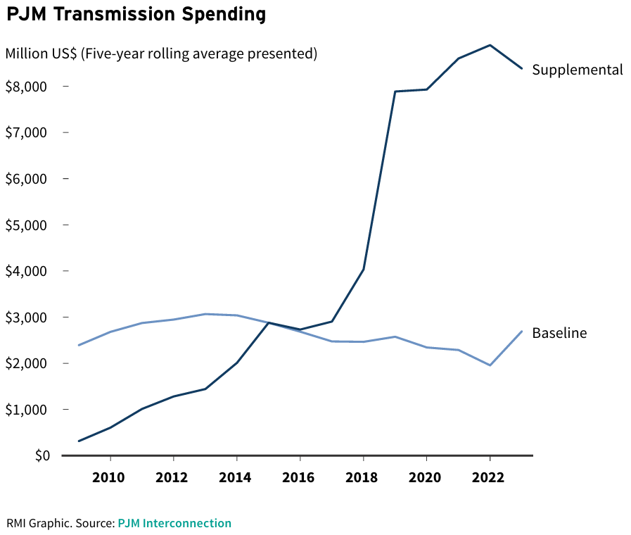

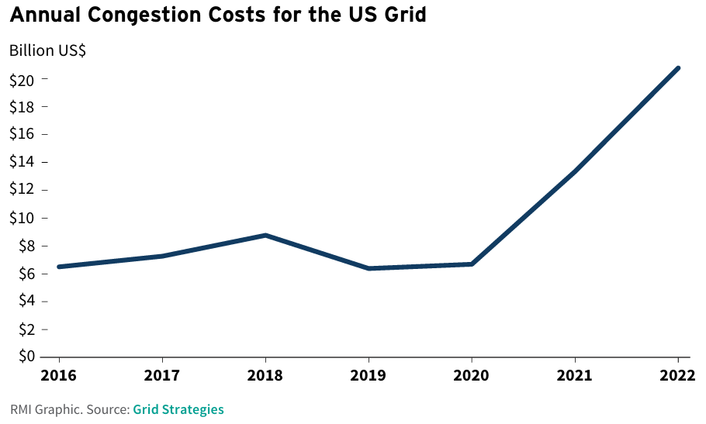

Source: RMI. 2025. Mind the regulatory gap.

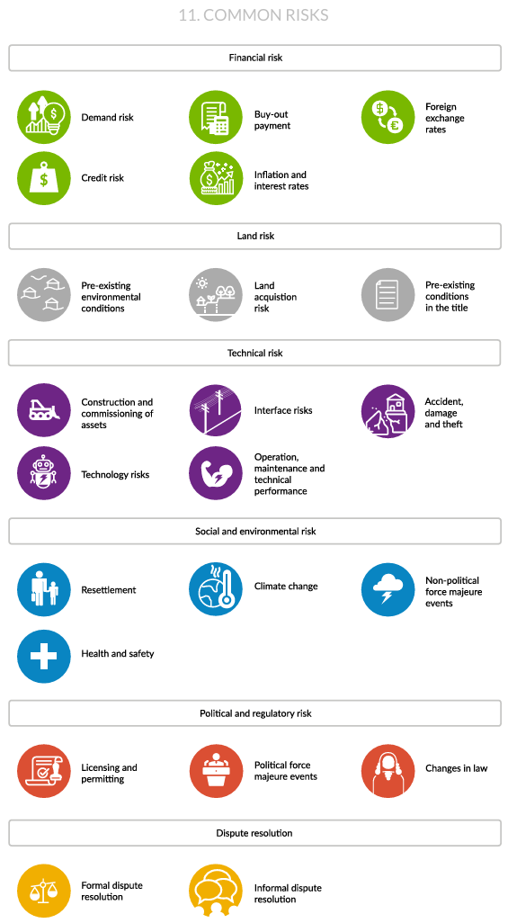

Source: US Department of Commerce. 2024. Understanding transmission financing.

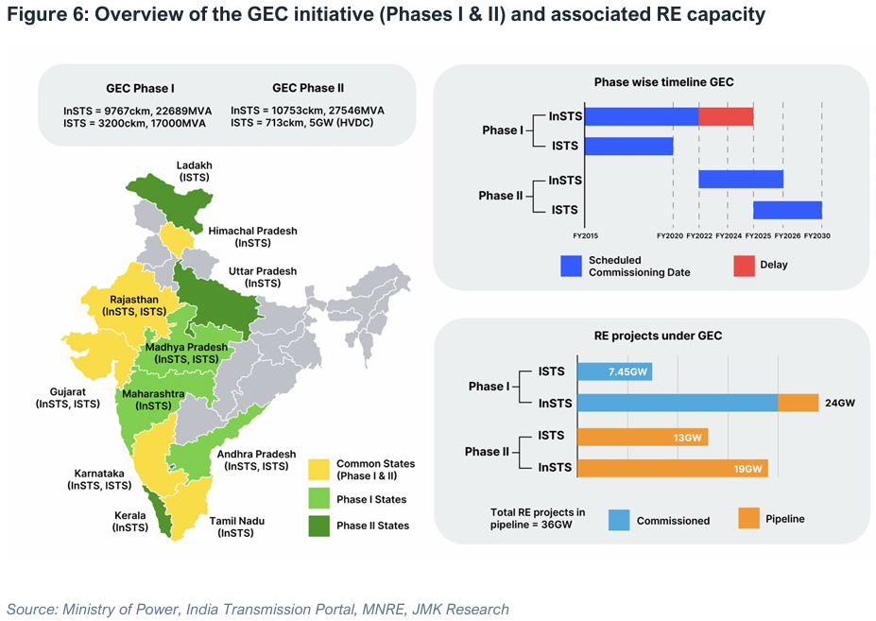

Source: Source: Institute of Energy Economics and Financial Analysis. 2025. Green Power Transmission Development in India.

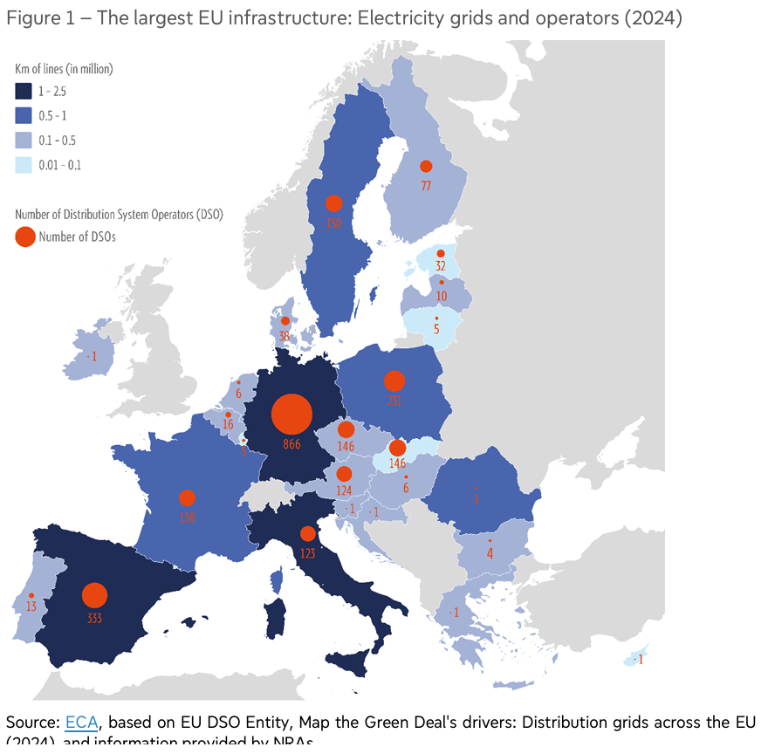

Source:

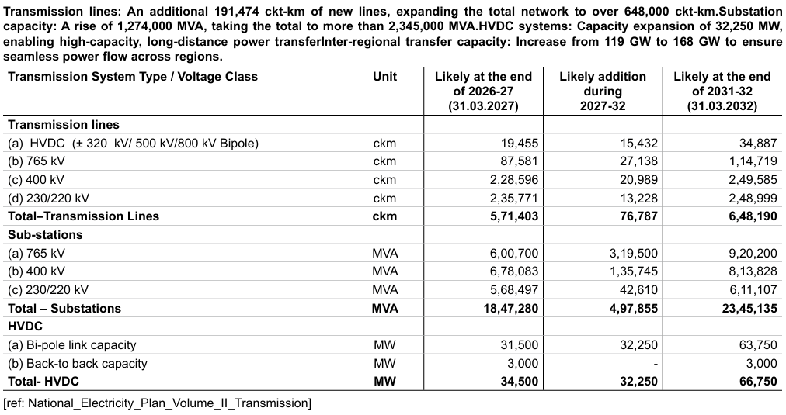

Source: Jyothy Structures. 2025. AR.